1. **Getting Started with Playwright TypeScript**
   1. What is Playwright and Advantages, Limitations
   2. Playwright Architecture
   3. Playwright Vs Cypress Vs Selenium WebDriver
   4. Software Requirement
   5. Download & Install NodeJS & VS Code
   6. Install Playwright using VS Code
   7. Default Playwright Folder Structure
   8. Playwright Test Explorer - Run Tests, Debug Tests, Filters
   9. Setup Playwright Test Automation using Command Prompt
   10. Record Test in VS Code
   11. Generate HTML Test Report
   12. Run Test on Google Chrome, Microsoft Edge & Firefox Browsers
   13. Generate Readable Playwright HTML Test Report
   14. Commonly used Terminologies
   15. First Playwright Automation Test
   16. Pick Locator in VS Code
   17. Record at Cursor
   18. Run Specific Spec File
   19. Run Test in Headless mode
   20. Run Test in Headed mode
   21. Run Test on Different Browsers using CMD
   22. Codegen – Record and Play Test
2. **Locators, Assertions, Hooks, Annotations & Actions**
   1. Screenshots
   2. Add Screenshots to HTML Report when Test failed
   3. Locators
   4. Hooks
   5. Handling Dropdown List
   6. IFrames, Drag & Drop
   7. Mouse Actions
   8. Keyboard Actions
   9. Date Picker
   10. Assertions - Hard & Soft Assertions
   11. Watch mode
   12. Playwright UI
   13. Trace Viewer - Test Traces, Actions metadata, Console, Log, Network
3. **Retry, Repeat, Tags, Visual Testing**
   1. Annotations – Skip Test, Only
   2. Grouping Tests
   3. Tag Test
   4. Repeat
   5. Retry
   6. Parametrize Tests
   7. Visual Comparison - Visual Testing
   8. Timeouts
4. **Rerun Failed Tests, Browser Context, Popup’s, Alerts etc.**
   1. tsconfig.json file
   2. Browser Context – Open multiple browser sessions/tabs/pages
   3. Rerun only failed Tests
   4. Popups/Alerts/Dialogues
   5. Generate Multiple Test Reports
   6. Video Recording
   7. Parallelism/Parallel Test Execution
   8. Allure Report with Playwright
   9. textContent (), innerText (), getAttribute()
   10. Iterate through all the matching elements
   11. Checkbox, Radio Buttons.
5. **Page Object Model, Video, Environments, Data Driven Testing**
   1. Env File
   2. Data Driven Testing Using JSON File
   3. Data Driven Testing Using CSV File
   4. Data Driven Testing Using EXCEL File
   5. Page Object Model
   6. Run Only Changed Spec Files
   7. Full Screen Browser & Set ViewPort Size
   8. Fixture - Implementing Global Hooks
   9. Optimizing POM Tests using Fixture
   10. Run Tests on Multiple Environments – QA, STAGE, DEV, PROD etc.
   11. Global Setup & TearDown - Authentication- Saving Login State
6. **API Automation - API Mocking + GET, POST, PUT, PATCH & DELETE** 
   1. POST API Request using Static JSON Object
   2. POST API Request using Dynamic JSON Object
   3. POST API Request using TypeSafety Approach
   4. GET API Request
   5. Query Parameter
   6. PUT API Request
   7. PATCH API Request
   8. DELETE API Request
   9. Mock API Requests
   10. Mock API Response
   11. Mocking with HAR files - Recording, Modifying & Replaying
7. **Playwright with CI CD Tools (Jenkins, Azure DevOps Pipeline & GitHub Actions)**

**7.1 How to Integrate Playwright with Jenkins + GitHub**

- How to Create GitHub Repository & Push Code?

- Generate PAT (Personal Access Token) for GitHub?

- How to Download & Setup Jenkins?

- Install Plugins:

- NodeJS Plugin, Git Plugin, JUnit Plugin &

Allure Plugin.

- How to Add GitHub PAT token in Jenkins?

- How to Create Jenkins Job & Run Playwright Tests?

- How to Attach Artifacts (playwright-report)

- How to Publish Junit Test Results in Jenkins?

- How to Publish Allure Report in Jenkins?

**7.2 How to Integrate Playwright with Azure DevOps Pipeline**

- Download & Install GIT - <https://git-scm.com/downloads>

- How to Install Azure Repos extension in VS Code

- How to Create New Repository in Azure DevOps?

- How to Push Source Code from VS Code to Azure DevOps?

- How to Create .yml (YAML) file?

- How to Create Azure DevOps Pipeline?

- How to Run Playwright Tests using ADO pipeline?

- How to Publish JUnit Test Results in ADO?

- How to Attach “playwright-report” in ADO as Artifacts?

- How to Update Test Case Status Automatically in

Test Plan (Pipeline + Local)?

**7.3 Integrate Playwright with GitHub Actions:**

- How to Create .yml (YAML) File?

- How to Run Playwright Tests using GitHub Actions?

- Workflow - Auto Trigger

- Workflow - Manual Trigger

- How to Attach “playwright-report“ as Artifacts

1. **File Uploading, Downloading & Content Validation**
   1. **Upload File**
   2. **Download File**
   3. **Validate Downloaded Excel File Content**
   4. **Validate Downloaded XML File Content**
   5. **Validate Downloaded PDF File Content**
   6. **Validate Downloaded Word Doc. File Content**

*** **Refer “Playwright TypeScript by Testers Talk” Playlist in YouTube** ***

https://youtube.com/playlist?list=PLUeDIlio4THEXmQxNvKmdDxAVloGTHXMr&feature=shared

*** **Subscribe to YouTube channel to get latest software testing updates** ***

https://www.youtube.com/@testerstalk?sub_confirmation=1

*** **Learn FREELY more from Testers Talk channel** ***

1. **Playwright with JavaScript Full Course:**

https://youtube.com/playlist?list=PLUeDIlio4THFSOUcVo_Cfam8I_IO483mV&feature=shared

1. **JavaScript Beginners Course:**

https://youtube.com/playlist?list=PLUeDIlio4THFLrS29tJnP9yz-QKhn4mdB&feature=shared

1. **Cypress Full Course:**

https://youtube.com/playlist?list=PLUeDIlio4THEbdE2jWyBBxkWqjk4JmHHq&feature=shared

1. **Postman API Testing (Manual + Automation) Full Course:**

https://youtube.com/playlist?list=PLUeDIlio4THGcgNP3_Ocb_I_l4ITai5QT&feature=shared

1. **Rest Assured API Automation Full Course:**

https://youtube.com/playlist?list=PLUeDIlio4THGL7lQXQwxsV9re_i0U2b0Q&feature=shared

1. **Specflow Selenium C# Full Course:**

https://youtube.com/playlist?list=PLUeDIlio4THGmh41cgOGHMPxAJyK44WrA&feature=shared

1. **Playwright with TypeScript UI Automation - Part01**

Link: <https://youtu.be/788GvvcfwTY?feature=shared>

**[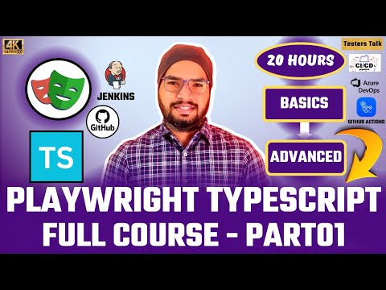](https://www.youtube.com/embed/788GvvcfwTY?feature=oembed)**

**2. Playwright with TypeScript UI Automation - Part02**

Link: https://youtu.be/YfRazDhi9Fw?feature=shared

**[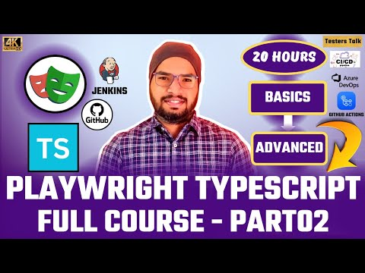](https://www.youtube.com/embed/YfRazDhi9Fw?feature=oembed)**

1. **Playwright with TypeScript API Automation + Mocking – Part03**

Link: https://youtu.be/iGQ-qTLEPLw?feature=shared

**[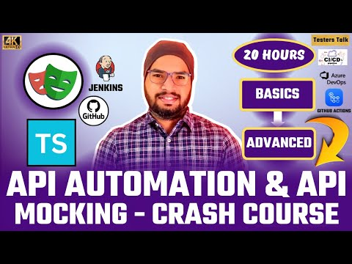](https://www.youtube.com/embed/iGQ-qTLEPLw?feature=oembed)**

1. **Playwright with CICD Tools – Part04**

**(Jenkins, Azure DevOps & GitHub Actions + Test Reports)**

Link: https://youtu.be/D44k45N6S58?feature=shared

**[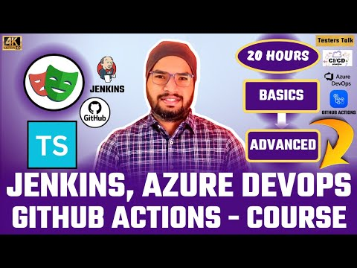](https://www.youtube.com/embed/D44k45N6S58?feature=oembed)**

**\*\*\* Topic wise breakdown tutorials \*\*\***

1. Getting Started with Playwright & TypeScript

**1.1 What is Playwright and Advantages, Limitations**

**[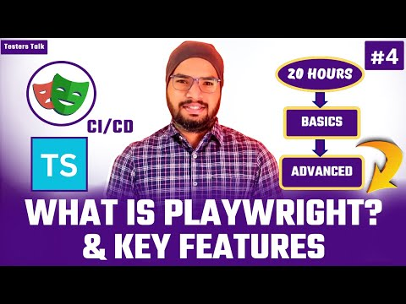](https://www.youtube.com/embed/CTKgB_3kXSg?feature=oembed)**

Playwright is an open-source automation testing tool which is used test end to end modern web mobile applications in headed or headless mode.

Advantages:

* Cross Browser Testing - Chrome, Edge, Chromium, Firefox & Webkit.
* Cross Platform Testing - Windows, Linux & MacOS.
* Cross Programming Language - TypeScript, JavaScript, Python, .NET & Java.
* Test Mobile Web - Mobile emulation of Google Chrome for Android and Mobile Safari.
* Auto Wait - Example: Click action
* Trace Viewer
* Reporting
* Parallel Execution
* No trade-off & No limit - Cross origin domain support
* Dynamic Wait Assertions
* Faster & Reliable
* State Saving - Example: Application Login
* Powerful Tooling – Codegen, Playwright Inspector & Trace Viewer
* No flaky test

Limitations/Disadvantages:

* Resource Consumption: As it runs on real browser instances This can be a problematic when parallel execution is happening with a system with limited resources
* Playwright does not support for desktop application automation.
* It does support for legacy browsers such Internet Explorer.
* Playwright does not have a big community compared to selenium WebDriver.

**1.2 Playwright Architecture**

[**https://youtu.be/0mn6zKjiMGg?si=8IYq3JkfqgD9eQln**](https://youtu.be/0mn6zKjiMGg?si=8IYq3JkfqgD9eQln)

**[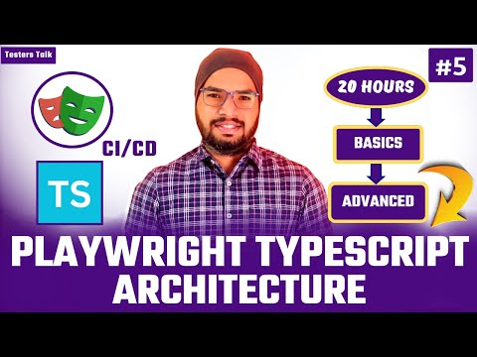](https://www.youtube.com/embed/0mn6zKjiMGg?feature=oembed)**

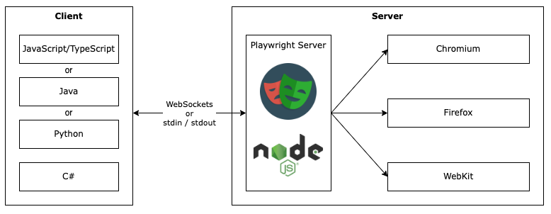

* Client: In the client side our automation test code will be written in different languages such as typescript, JavaScript, python, c# .net etc.
* Server: The server communicates between client and web browser engines such as chrome, Firefox, edge etc.

Playwright uses CDP to communicate with chromium or chrome browser, similarly playwright has implemented CDP to communicate with other browser such as Firefox webkit etc.

* WebSocket Protocol: WebSocket connection is established to the server from client by using process called Web Socket Handshake, WebSocket sends response as soon as it gets request in real time. Connection will be not terminated until unless connection is closed by either client or server.
* CDP (Chrome DevTools Protocol):
* Client & Server Communication: When test is triggered Client converts automation test into JSON format and sends to server over WebSocket Protocol
* Playwright communicates all the request over single web-socket protocol connection.
* Test failure & test flakiness is less as because executing all the tests over single web-socket connection.

**1.3 Playwright Vs Cypress vs Selenium WebDriver**

<https://youtu.be/u8DKhL9uO2A?si=kFjgNjzpU-1InyGd>

[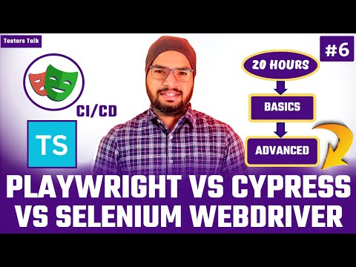](https://www.youtube.com/embed/u8DKhL9uO2A?feature=oembed)

|  |  |  |  |
| --- | --- | --- | --- |
| **Feature** | **Playwright** | **Cypress** | **Selenium** |

|  |  |  |  |
| --- | --- | --- | --- |
| **Setup Complexity** | Very Easy with JS/TS | Simple and fast setup (JS-based) | High (configuration and dependencies) |

|  |  |  |  |
| --- | --- | --- | --- |
| **Language Support** | TypeScript/JavaScript, Python, C#, Java | JavaScript/TypeScript only | Java, Python, JavaScript, C#, Ruby, and more |

|  |  |  |  |
| --- | --- | --- | --- |
| **Speed** | Very fast (headless support, parallel execution) | Fast (runs inside browser) | Slower (WebDriver protocol overhead) |

|  |  |  |  |
| --- | --- | --- | --- |
| **Browser Support** | Chromium, Chrome, Edge, Firefox, WebKit (Safari) | Chrome, Edge, Electron | All major browsers (Chrome, Firefox, Edge, Safari, IE) |

|  |  |  |  |
| --- | --- | --- | --- |
| **Parallel Execution** | Yes | No | No |

|  |  |  |  |
| --- | --- | --- | --- |
| **Debugging** | Excellent (built-in tools, browser contexts) | Excellent (real-time feedback, snapshots) | No support |

|  |  |  |  |
| --- | --- | --- | --- |
| **Cross-browser** | Yes | Limited (no Firefox/Safari support) | Yes |

|  |  |  |  |
| --- | --- | --- | --- |
| **Community Support** | Growing rapidly | Very strong in the JavaScript community | Large, mature community |

**1.4 Software Requirement -**

<https://youtu.be/TJ_V3BGtTRI?si=oe8F00v8axJuIR3z>

[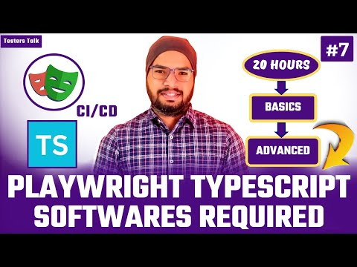](https://www.youtube.com/embed/TJ_V3BGtTRI?feature=oembed)

1. NodeJS
2. Visual Studio Code (VS Code)
3. TypeScript
4. Operating System - Window/MAC/Linux
5. GIT/GitHub
6. Azure DevOps/GitHub Actions
7. Postman Tool for manual API Testing Flow
8. Android Studio for Mobile App Testing

**1.5 Install NodeJS & VS Code**

<https://youtu.be/TkdZymnGZhs?si=LJUa3ka-SZKrx-mP>

[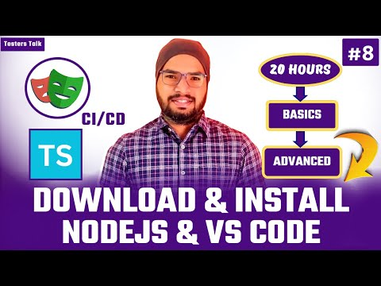](https://www.youtube.com/embed/TkdZymnGZhs?feature=oembed)

a) NodeJS – Download & Install

b) Visual Studio Code (VS Code) - Download & Install

**1.6 Install Playwright using VS Code**

[**https://youtu.be/-kccujLmsDs?si=K5eJneZZM-vYcQ6Q**](https://youtu.be/-kccujLmsDs?si=K5eJneZZM-vYcQ6Q)

**[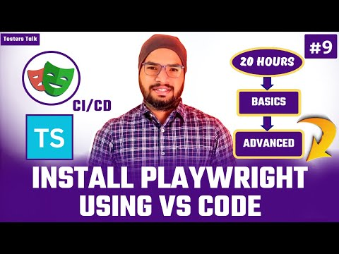](https://www.youtube.com/embed/-kccujLmsDs?feature=oembed)**

Step1: We need to install “Playwright Test for VSCode” extension.

Step2: Press Ctrl+Shift+P or Command+Shift+P, enter “install playwright”

Step3: Select Playwright configurations & click on “OK”

Then wait for some time to complete the installation.

**1.7 Playwright Default Folder Structure**

<https://youtu.be/F48g0-LGAos?si=Gkh3f-Bw6bJDI6JE>

[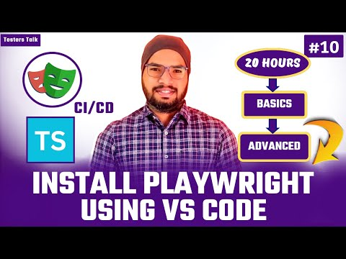](https://www.youtube.com/embed/F48g0-LGAos?feature=oembed)

**1.8 Test Explorer:**

[**https://youtu.be/RSo4RrdW4Mg?si=s8_QIOg-z8gP9IOg**](https://youtu.be/RSo4RrdW4Mg?si=s8_QIOg-z8gP9IOg)

**[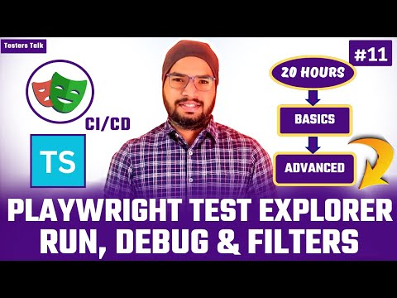](https://www.youtube.com/embed/RSo4RrdW4Mg?feature=oembed)**

- Run, Debug Tests, Filter

**1.9 Setup Playwright Test Automation using CMD or Terminal**

<https://youtu.be/_KTzU4Gf1_Q?si=UQo-BrklmJd3wUZx>

[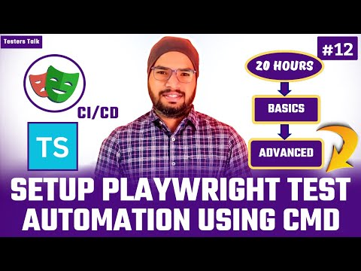](https://www.youtube.com/embed/_KTzU4Gf1_Q?feature=oembed)

- Install:

Command: npm init playwright@latest

* + - * Choose between TypeScript or JavaScript (default is TypeScript)
      * Name of your Tests folder (default is tests folder)
      * Add a GitHub Actions workflow to easily run tests on CI
      * Install Playwright browsers (default is true)

- Run Test

- Playwright HTML Test Report

**1.10 Record Test in VS Code**

- Manual Test Scenario

- Record Test

- Run Test

- Playwright HTML Test Report

<https://youtu.be/LxDrCdnVhQo?si=z2YDP_R0Rq8nABPH>

[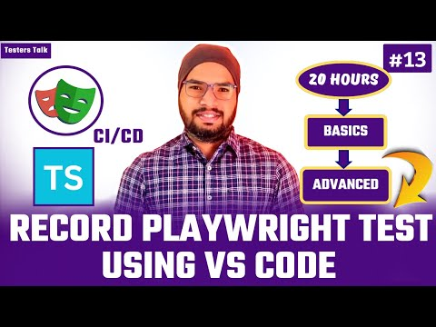](https://www.youtube.com/embed/LxDrCdnVhQo?feature=oembed)

**1.12 Run Test on Google Chrome, Microsoft Edge & Firefox Browsers**

<https://youtu.be/8C_fphAZ_Ic?si=T5RCIPNSqyPzMTe8>

[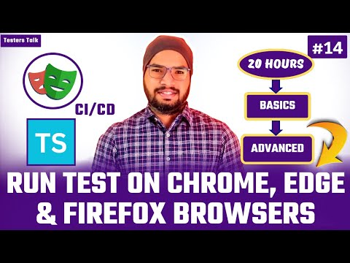](https://www.youtube.com/embed/8C_fphAZ_Ic?feature=oembed)

**1.12 Generate Readable Playwright HTML Test Report**

<https://youtu.be/v0Yvwx7phuo?si=OsdEf1_0h2yvaliC>

[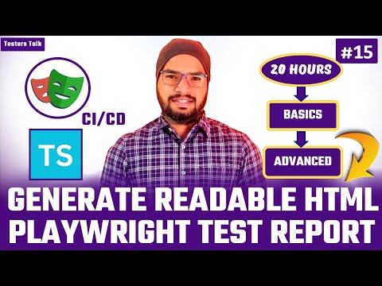](https://www.youtube.com/embed/v0Yvwx7phuo?feature=oembed)

**1.14 Commonly used Terminologies in Playwright Testing**

[**https://youtu.be/r57xT1kfl8A?si=TS4_MLfeay73MFOq**](https://youtu.be/r57xT1kfl8A?si=TS4_MLfeay73MFOq)

**[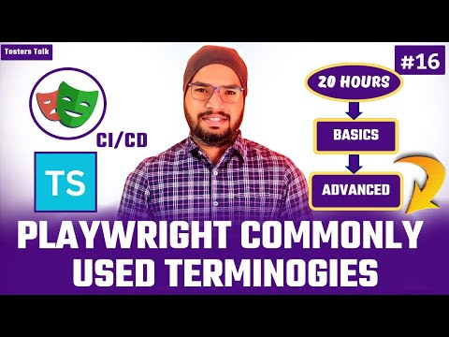](https://www.youtube.com/embed/r57xT1kfl8A?feature=oembed)**

- async & await, test, page, expect

* What is async & await? - async is a function, await is valid inside async function only.
* Zero or more await expressions can be written inside async function
* When each time async functions is called, which will return resolved promised value or rejected with an exception details.
* What is test?

The test function is used to define an individual test. It provides a way to structure and organize your tests by giving them a name and it takes 2 arguments.

- First argument is test case title

- Second argument is async()

* What is page?

It is a browser page object, it allows you to interact with web browser & perform actions like click, typing into input fields etc.

Also, it provides access to various methods to interact with web browser.

* What is expect?

Playwright's expect is powerful and provides a rich set of matchers for various types of checks, such as checking element visibility, text content, existence etc.

* It lets you write better assertions for end-to-end testing.

**1.15 First Playwright Automation Test**

**1.16 How to use Pick Locator**

- Manual Test Scenario

- Automate Test Scenario

- How to use Pick Locator to identify element

- Run Playwright Test

- Playwright Test report

[**https://youtu.be/9io46lyZlCc?si=MEijgDoyUXiFhpCp**](https://youtu.be/9io46lyZlCc?si=MEijgDoyUXiFhpCp)

**[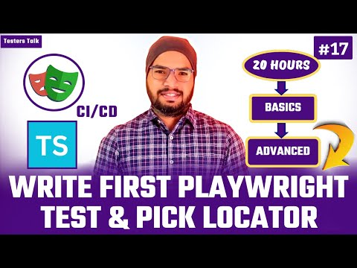](https://www.youtube.com/embed/9io46lyZlCc?feature=oembed)**

**1.17 Record at Cursor**

[**https://youtu.be/letbosZsGo8?si=X2hxdL7Dylaa3HZ6**](https://youtu.be/letbosZsGo8?si=X2hxdL7Dylaa3HZ6)

**[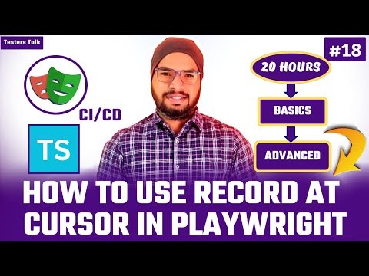](https://www.youtube.com/embed/letbosZsGo8?feature=oembed)**

**1.18 How to Run Specific Spec File?**

[**https://youtu.be/rb5C4-3w_7c?si=ec53KZtWo8WXzE0B**](https://youtu.be/rb5C4-3w_7c?si=ec53KZtWo8WXzE0B)

**[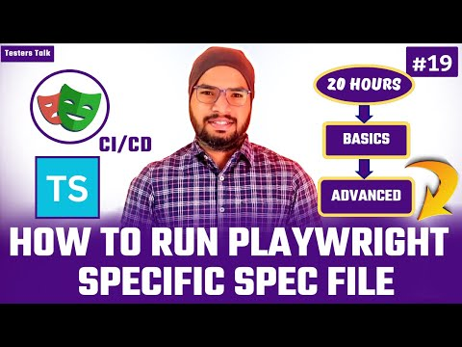](https://www.youtube.com/embed/rb5C4-3w_7c?feature=oembed)**

**1.19 How to Run Playwright Test in Headless mode?**

<https://youtu.be/QNzw0xrWhPY?si=eu1LCeFD3-71hdq0>

[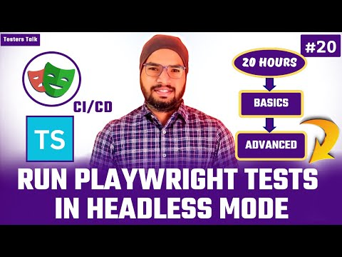](https://www.youtube.com/embed/QNzw0xrWhPY?feature=oembed)

**1.20 How to Run Playwright Test in Headed mode?**

<https://youtu.be/Ushdk7FKRqI?si=UNig-3UGIwmq6kH6>

[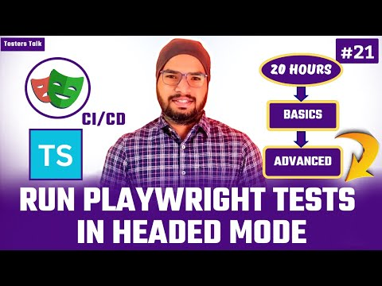](https://www.youtube.com/embed/Ushdk7FKRqI?feature=oembed)

**1.21 How to Run Playwright Test on Different Browsers using Terminal/CMD**

<https://youtu.be/zqnD6T03fv0?si=cACXDNJq3YFZTwi0>

[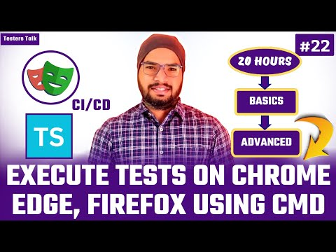](https://www.youtube.com/embed/zqnD6T03fv0?feature=oembed)

**1.22 Codegen – Record and Play Test**

- Manual Test Scenario

- Using Codegen

- Create Spec File

- Run Test

- Playwright Test Report

<https://youtu.be/8WfwUHhAAlo?si=liSHIb6FY2Qvpets>

[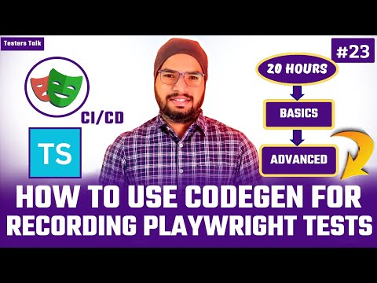](https://www.youtube.com/embed/8WfwUHhAAlo?feature=oembed)

Chapter- 02

**2.1 How to Capture Screenshots in Playwright?**

- Element screenshot

- Page screenshot

- Full Page screenshot

<https://youtu.be/0i0U9MSxJpc?si=wpv3pbrv5lqmAgpE>

[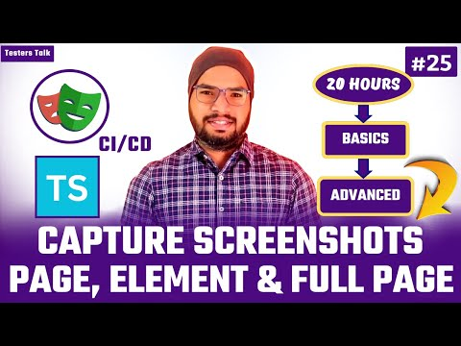](https://www.youtube.com/embed/0i0U9MSxJpc?feature=oembed)

**2.2 How to Add Screenshots to Playwright HTML Test Report**

- When Test is Failed

- When Test is Passed

<https://youtu.be/jF-hneihfJE?si=yjdIEF1FjaRPM6R9>

[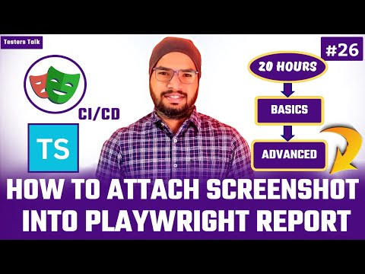](https://www.youtube.com/embed/jF-hneihfJE?feature=oembed)

**2.3 Locators Strategy in Playwright Test Automation**

<https://youtu.be/cuZbPdmYTz0?si=ChPpowOB9NWCP58M>

[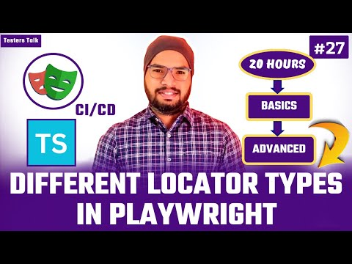](https://www.youtube.com/embed/cuZbPdmYTz0?feature=oembed)

a) By Role

Example - await page.getByRole(‘link’,{name: ‘value’}).click()

b) By Label

Example - await page.getByLabel(‘value’,{exact : true}).fill(‘value’);

c) By Alt Attribute - For images

Example - await page.getByAltText(‘alt attribute value’).click();

d) By Test Id - For Custom Attributes

Example - await page.getByTestId(‘value).fill(‘testers talk’);

e) By Text

Example - await page.getByText(‘any text’).click(); //partial

Example - await page.getByText(‘any text’, {exact :true}).click();

f) By Placeholder

Example - await page.getByPlaceholder(‘value]).click();

g) XPath

Example - await page.locator(“xpath=//*[@attr=’value’]”).click();

Example - await page.locator(“//*[@attr=’value’]”).click();

h) CSS Selector

Example - await page.locator (“css=tagname[@attr=’value’]”).click();

Example - await page.locator (“tagname[@attr=’value’]”).click();

i) By Title

Example - await page.getByTitle(‘playwright by testers talk).click();

**2.4 How to Implement Hooks in Playwright?**

i) beforeAll()

ii) beforeEach()

iii) afterEach()

iv) afterAll()

<https://youtu.be/URfl51R6XyU?si=ygwoF1sKoRvHFD4G>

[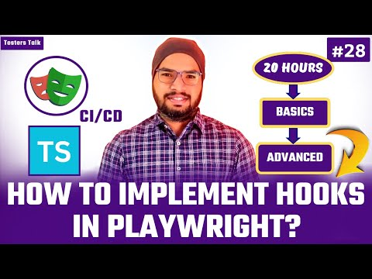](https://www.youtube.com/embed/URfl51R6XyU?feature=oembed)

**2.5 Handling Dropdown List**

- Manual Test Scenario

- Selecting Dropdowns Value using Value

- Selecting Dropdowns using Visible Text

- Validate Dropdown options

[‘Jan’, 'Feb', 'Mar','Apr', 'May', 'Jun', 'Jul','Aug', 'Sep', 'Oct', 'Nov', 'Dec']

<https://youtu.be/dlP-4N_Vd2k?si=SSFp5tx0-jkEWfMh>

[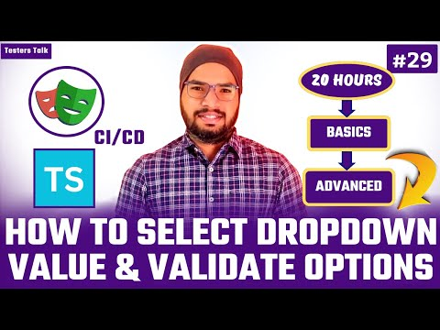](https://www.youtube.com/embed/dlP-4N_Vd2k?feature=oembed)

**2.6 How to Switch into IFrames in Playwright?**

- How to Drag and Drop Elements in Playwright?

<https://youtu.be/pwUxspaA4kY?si=yIMZyqlgOwx6U_nu>

[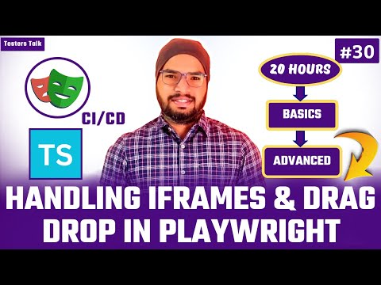](https://www.youtube.com/embed/pwUxspaA4kY?feature=oembed)

**2.7 How to perform Mouse Actions in Playwright?**

- Mouse Left/Middle/Right Button Clicks

- Mouse Hover

- Double Click

<https://youtu.be/7WkWQYrmb0k?si=NybEl-H-F71EsSKv>

[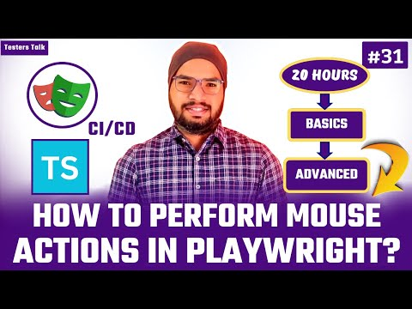](https://www.youtube.com/embed/7WkWQYrmb0k?feature=oembed)

**2.8 How to perform Keyboard Actions in Playwright?**

- How to Press ‘Enter’, ‘Tab’, ‘Delete’ & ‘Control+A’ or ‘Meta+A’ etc.

<https://youtu.be/RWT91MHrYhI?si=HyphRdzskaff_QKZ>

[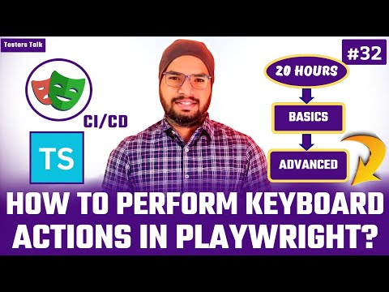](https://www.youtube.com/embed/RWT91MHrYhI?feature=oembed)

**2.9 How to Handle Date Picker in Playwright?**

- Hardcode Date

- Dynamically Selecting Date

- Selecting Past Date

- Selecting Future Date

<https://youtu.be/J9MyZaxZ29Y?si=1ONEJeKy1MLM6oqO>

[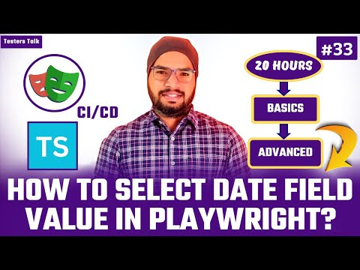](https://www.youtube.com/embed/J9MyZaxZ29Y?feature=oembed)

**2.10 Assertions in Playwright Test Automation**

[**https://youtu.be/hVsOvwpXfnY?si=MMCUlP8E25mkjoUX**](https://youtu.be/hVsOvwpXfnY?si=MMCUlP8E25mkjoUX)

**[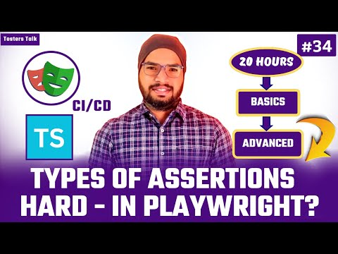](https://www.youtube.com/embed/hVsOvwpXfnY?feature=oembed)**

[**https://youtu.be/jQOeqM7UrCQ?si=bIICD6DCfYNBOL-y**](https://youtu.be/jQOeqM7UrCQ?si=bIICD6DCfYNBOL-y)

**[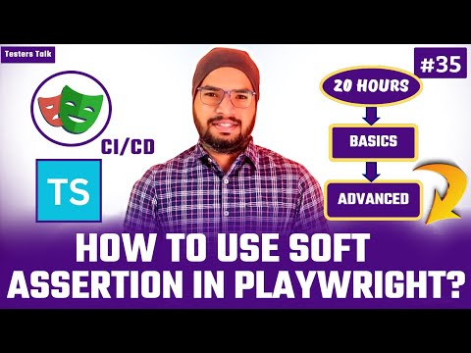](https://www.youtube.com/embed/jQOeqM7UrCQ?feature=oembed)**

There are 2 types of assertions

1) Hard Assertion

2) Soft Assertion

1) Hard Assertion

b) Editable - toBeEditable()

b) Visible - toBeVisible ()

c) Enabled - toBeEnabled ()

d) Empty - toBeEmpty ()

e) URL - toHaveURL ()

f) Title - toHaveTitle ()

g) Text - toHaveText ()

h) Count - toHaveCount ()

i) Disabled - toBeDisabled ()

**2.11 Watch Mode**

- Project level

- Spec file level

- Test level

<https://youtu.be/_tgNpYCIr8Y?si=sQMrNosIsUWWK6ox>

[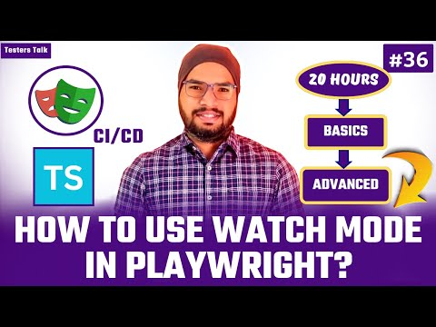](https://www.youtube.com/embed/_tgNpYCIr8Y?feature=oembed)

**2.12 Playwright UI**

[**https://youtu.be/XVeUcQFVoMQ?si=DMiUHrU1BR8aBS8E**](https://youtu.be/XVeUcQFVoMQ?si=DMiUHrU1BR8aBS8E)

**[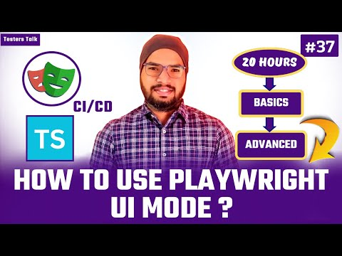](https://www.youtube.com/embed/XVeUcQFVoMQ?feature=oembed)**

# 2.13 Trace Viewer - Test Traces, Actions, Metadata, Console, Log, Network etc.

<https://youtu.be/isnkATBZ3BU?si=f-Cp8dDKJMM45Lve>

[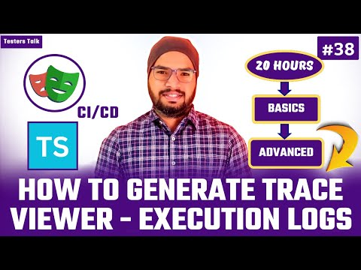](https://www.youtube.com/embed/isnkATBZ3BU?feature=oembed)

Chapter- 03

# 3.1 Annotations

# - Skip Test,

# - Only (Run only selected test)

<https://youtu.be/7p5xORtF_GY?si=MVxN6ZFRV6JXQaPj>

[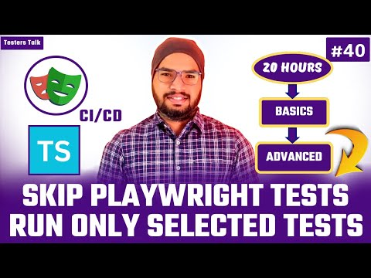](https://www.youtube.com/embed/7p5xORtF_GY?feature=oembed)

# 3.2 How to Group & Run Tests in Playwright?

<https://youtu.be/0jEWcCYPqS0?si=YHDLf-98ujs9sGhi>

[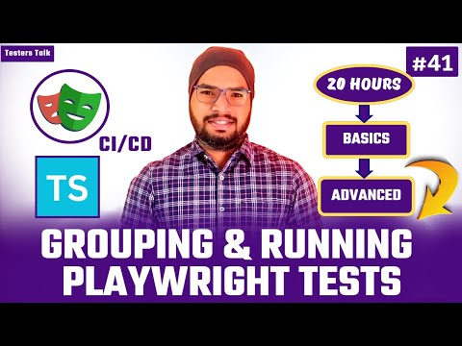](https://www.youtube.com/embed/0jEWcCYPqS0?feature=oembed)

# 3.3 Tags in Playwright Test Automation?

<https://youtu.be/qSkzQV3lXtM?si=KZt3uea3na1GZEvi>

[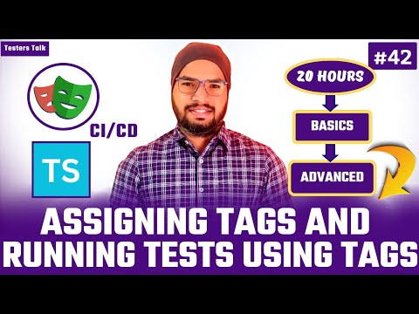](https://www.youtube.com/embed/qSkzQV3lXtM?feature=oembed)

# 3.4 How to Run Same Test multiple times in Playwright?

<https://youtu.be/W7B9sd7NtMM?si=rburClMjA5-QxiFp>

[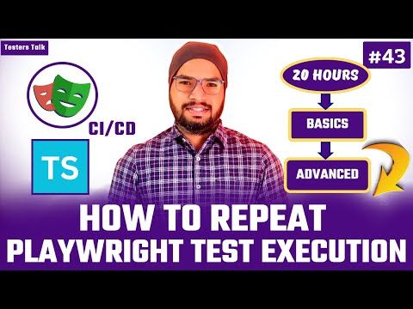](https://www.youtube.com/embed/W7B9sd7NtMM?feature=oembed)

# 3.5 How to Automatically Retry Test Execution When Test is Failed in Playwright?

<https://youtu.be/LTujQSv8nAA?si=SU9JUuoOJuMtk7ol>

[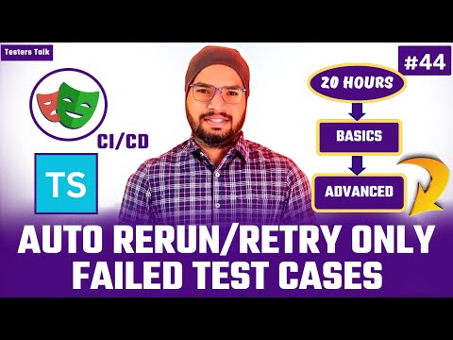](https://www.youtube.com/embed/LTujQSv8nAA?feature=oembed)

# 

# 3.6 How to Parametrize Tests in Playwright?

<https://youtu.be/x_xmdPdH6Is?si=yYNfGzZ1l0RIJRkZ>

[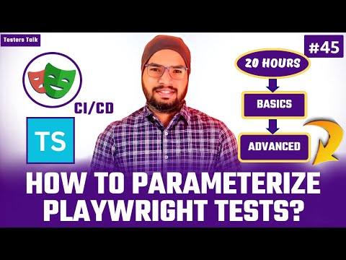](https://www.youtube.com/embed/x_xmdPdH6Is?feature=oembed)

# 3.7 How to Perform Visual Testing in Playwright?

- Testing Page Screenshot

- Testing Element Screenshot

<https://youtu.be/WLWuzXiyxco?si=3UkmtnL6WNGXrNdK>

[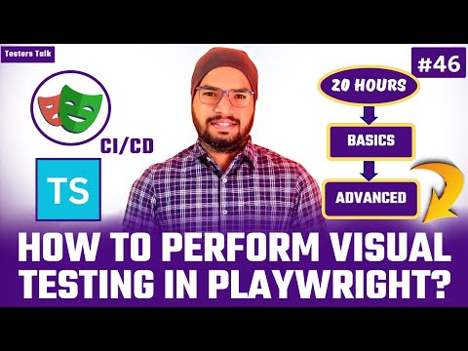](https://www.youtube.com/embed/WLWuzXiyxco?feature=oembed)

# 3.8 Timeouts in Playwright?

- Test Timeout

- Assertion Timeout

- Action Timeout

- All Test Execution Timeout

<https://youtu.be/kEwkksL3ZIA?si=9Rp17ZYfou2rJEXi>

[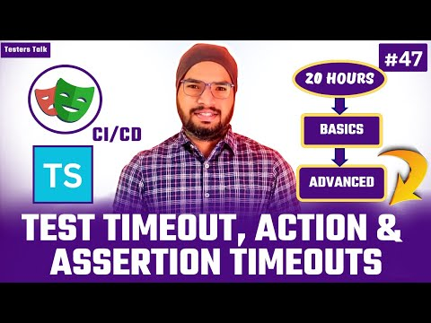](https://www.youtube.com/embed/kEwkksL3ZIA?feature=oembed)

Chapter- 04

# tsconfig.json file for Playwright with TypeScript

<https://youtu.be/SUTPHOuMDlA?si=dBQQk6-T2CiUH0KG>

[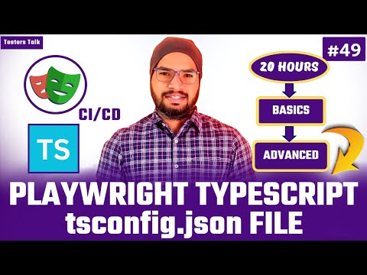](https://www.youtube.com/embed/SUTPHOuMDlA?feature=oembed)

The tsconfig.json file is the central place to configure TypeScript options for your project. Without it, TypeScript will default to certain behavior’s, which might not always suit your needs, especially as your project grows.

Benefits:

* Improves IDE Experience - Type Checking: Autocomplete, Error Reporting etc.

* Project-wide Configuration

* Integration with Build Tools - webpack etc.

* Build and Compilation - TypeScript to JavaScript(using tsc)

Here’s why you might want a tsconfig.json file:

* Specifies compiler options: You can define settings like target ECMAScript version ("target": "ESNext"), module system ("module": "CommonJS"), and other TypeScript-specific settings.
* Strict mode: You can enable strict mode and other TypeScript checks like strictNullChecks, noImplicitAny, forceConsistentCasingInFileNames, etc., to ensure type safety.
* Including/Excluding files: You can specify which files or directories to include or exclude from compilation, helping TypeScript avoid unnecessary processing of unwanted files.

tsconfig.json file

{

"compilerOptions": {

"target": "ESNext", // Compile to the latest ECMAScript version

"module": "CommonJS", // Module system for Node.js compatibility

"moduleResolution": "node", // Resolve modules like Node.js

"strict": true, // Enable all strict type-checking options

"esModuleInterop": true, // Allows default imports for CommonJS modules

"skipLibCheck": true, // Skip type checking of declaration files for faster builds

"forceConsistentCasingInFileNames": true, // Ensure consistent file naming

"outDir": "./dist", // Output directory for compiled JavaScript files

"rootDir": ".", // Root directory for TypeScript files

"resolveJsonModule": true, // Allow importing of JSON files

"types": ["node", "playwright"], // Include the types for Node.js and Playwright

"declaration": true, // Generate .d.ts files for type declarations

"sourceMap": true // Generate source maps for easier debugging

},

"include": [

"src/**/*.ts", // Include all TypeScript files in the 'src' folder

"tests/**/*.ts" // Include all TypeScript files in the 'tests' folder

],

"exclude": [

"node_modules", // Exclude node_modules from compilation

"dist" // Exclude the output directory

]

}

# 

# 4.2 Page, Browser Context etc.

# - How to create multiple browser sessions

# - How to create multiple tabs/pages

<https://youtu.be/WRA6T3MZJtc?si=ERvr29D9Rf_819ue>

[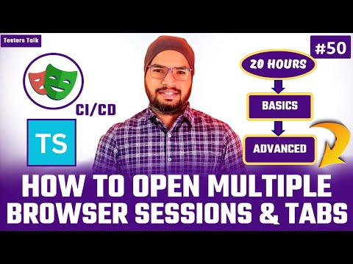](https://www.youtube.com/embed/WRA6T3MZJtc?feature=oembed)

# 

# 4.3 Rerun only failed Tests in Playwright?

<https://youtu.be/Cbye79CPeFI?si=Pq4mDkj-7GM1UEyd>

[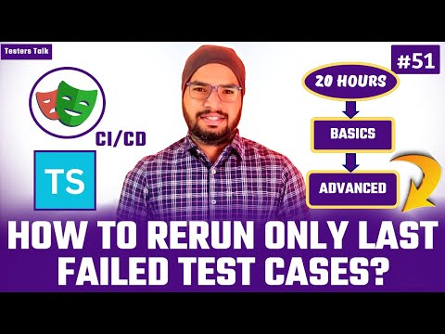](https://www.youtube.com/embed/Cbye79CPeFI?feature=oembed)

# 4.4 How to Handle Popups/Alerts/Dialogues in Playwright?

- Alerts

- Popups

- Prompt Popups

<https://youtu.be/_q25VaWFMzU?si=iHMm6eNp14OM8kfe>

[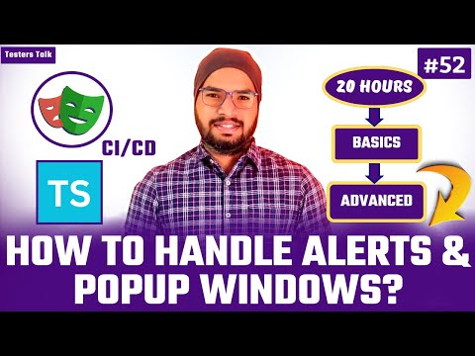](https://www.youtube.com/embed/_q25VaWFMzU?feature=oembed)

# 

# 4.5 How to Generate Multiple Types of Playwright Test Reports?

- HTML Test Report

- JSON Test report

- JUnit Test Report

- List Test Report

- Dot Test Report

- Allure Test Report

<https://youtu.be/wKKmvf3w31E?si=oGiJZfR4XQQEq87f>

[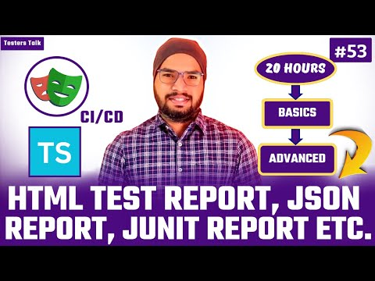](https://www.youtube.com/embed/wKKmvf3w31E?feature=oembed)

# 4.6 How to Enable Video Recording in Playwright?

<https://youtu.be/HrhgQtksxp0?si=pAJeSx1V2HOqOCIR>

[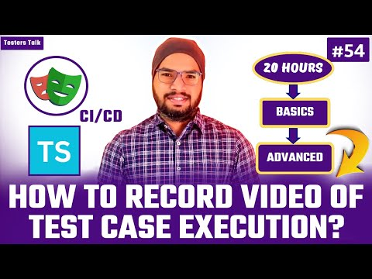](https://www.youtube.com/embed/HrhgQtksxp0?feature=oembed)

# 4.7 How to Perform Parallel/Parallelism Test Execution in Playwright?

- Config

- Command

<https://youtu.be/LYX7AFEADfU?si=enEzQBV5gk3QqbUS>

[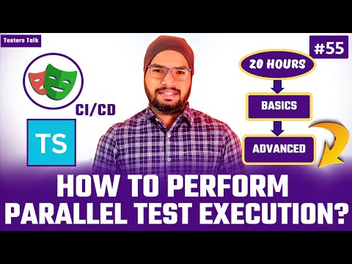](https://www.youtube.com/embed/LYX7AFEADfU?feature=oembed)

# 4.8 How to Generate Allure Report in Playwright?

<https://youtu.be/348WHEvihFU?si=phpC7pnzxsS6jdCg>

[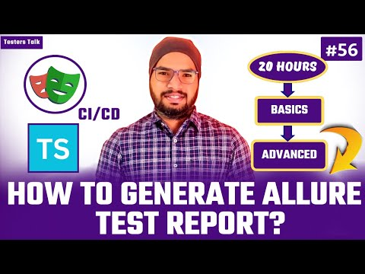](https://www.youtube.com/embed/348WHEvihFU?feature=oembed)

# 4.9 textContent (), innerText (), getAttribute()

<https://youtu.be/PQ5UI0ElHcM?si=xjfo4z46mO14OMH0>

[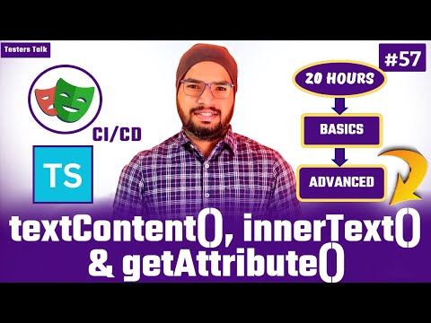](https://www.youtube.com/embed/PQ5UI0ElHcM?feature=oembed)

# 

# 4.10 How to Iterate through all the matching elements in Playwright.

- For of loop

- For loop

- For loop + nth() method

<https://youtu.be/0bKIVa1qBfU?si=C2f1mgbavG3OZ3Fb>

[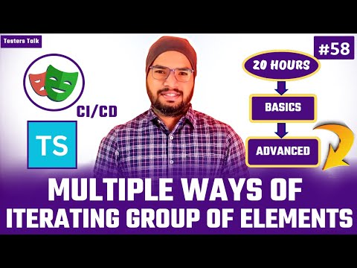](https://www.youtube.com/embed/0bKIVa1qBfU?feature=oembed)

# 

# 4.11 Handling Checkbox and Radio Buttons.

- Validate checked or unchecked

- How to check checkbox or radio buttons

<https://youtu.be/go7iUlUUftM?si=geV8s6YTb1JlRo8s>

[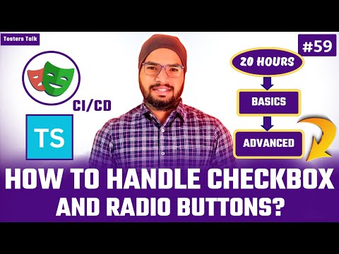](https://www.youtube.com/embed/go7iUlUUftM?feature=oembed)

Chapter- 05

# 5.1 How to Read .env File in Playwright with TypeScript?

- Plugin:

npm install dotenv –save

<https://youtu.be/m4c_OZAXIz4?si=DP-FNSfmA_F3lf3n>

[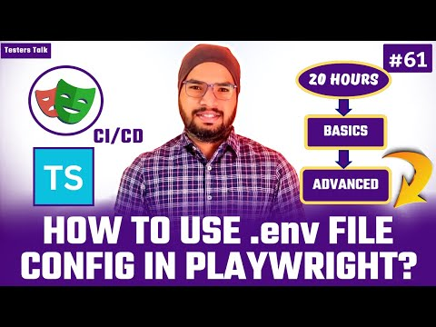](https://www.youtube.com/embed/m4c_OZAXIz4?feature=oembed)

# 5.2 How to Perform Data Driven Testing in Playwright with TypeScript Using JSON File?

- Create JSON file

- Read JSON file

- Pass each set of test data to playwright test

<https://youtu.be/b05fB2M2Geo?si=7SwydxBRJZblwFan>

[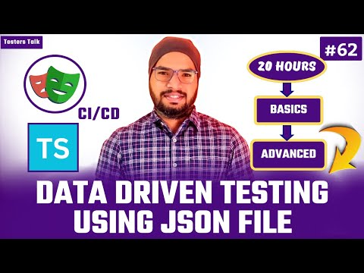](https://www.youtube.com/embed/b05fB2M2Geo?feature=oembed)

- If any file import issue add below code in global.d.ts file & include file tsconfig.json file:

declare module '*.json' {

const value: any;

export default value;

}

# 5.3 How to Perform Data Driven Testing in Playwright with TypeScript Using CSV File?

- Plugin:

npm install csv-parse

- Create CSV file

- Create new spec file

- Read CSV file

- Pass each set of test data to playwright test

<https://youtu.be/u7LPH_9xBrY?si=kbUkURjiemmoSyEt>

[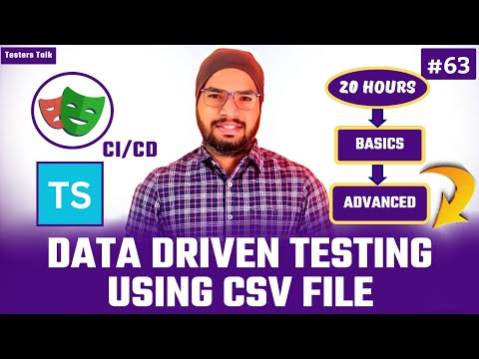](https://www.youtube.com/embed/u7LPH_9xBrY?feature=oembed)

- If any file import issue, add below code in global.d.ts file & include file tsconfig.json file:

declare module '*.csv' {

const value: any;

export default value;

}

# 5.4 How to Perform Data Driven Testing in Playwright with TypeScript Using EXCEL File?

- Plugin:

npm install xlsx

- Create Excel file with test data.

- Create utility function to read excel file.

- Create new spec file.

- Pass each set of test data to playwright test.

<https://youtu.be/uTKfr_ipxFU?si=7zpkr7WdNmXp328p>

[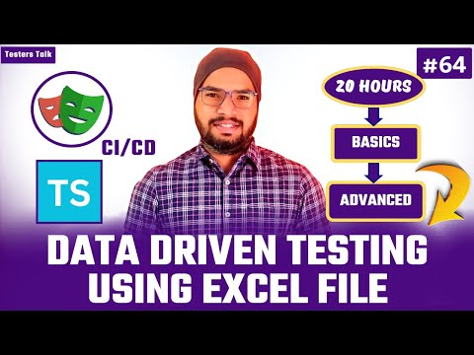](https://www.youtube.com/embed/uTKfr_ipxFU?feature=oembed)

5.5 Implement Page Object Model in Playwright

- Why Page Object Model?

- What is Page Object Model?

- Advantages & Disadvantages

- Sample Page Object Model Page Class

- Sample Page Object Model Playwright Test

- Use Case

- Create Pages

- Create Playwright Test using Page Object Model Design Pattern

<https://youtu.be/TNuVQ-ArPsQ?si=-8Fsm63FyeyR9CmH>

[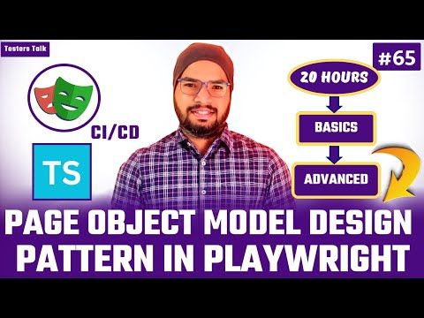](https://www.youtube.com/embed/TNuVQ-ArPsQ?feature=oembed)

- Why POM (Page Object Model)?

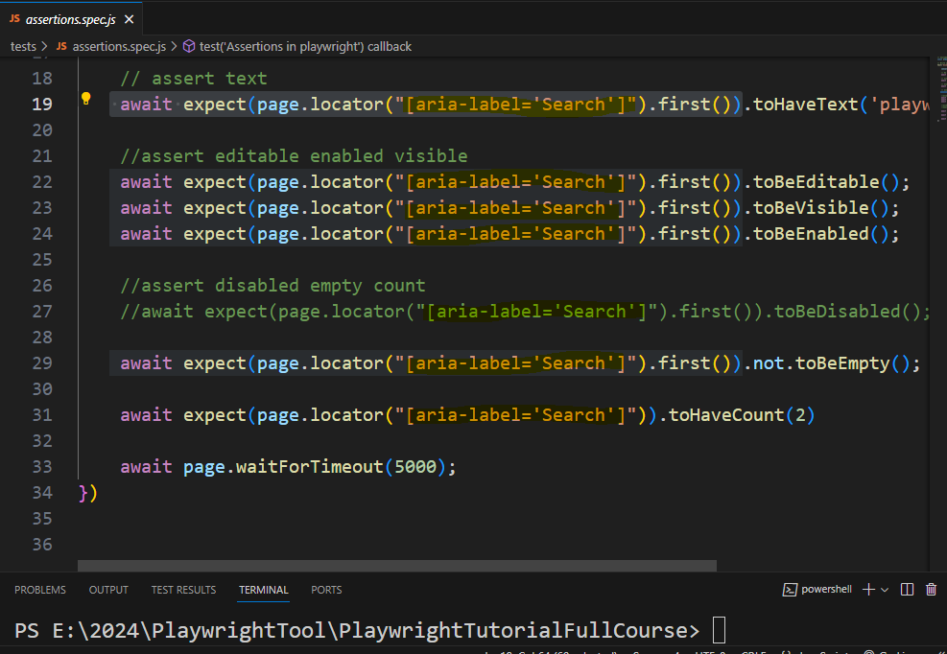

**- What is Page Object Model?**

* + - Page Object Model is a design pattern to create object repository for web page elements
    - For each web page there will be corresponding page class
    - Page class contains all the web page elements of that page & also it contains page methods which perform operations on those web elements

**- Advantages:**

* + - Code will be cleaner & Easier to understand
    - Object repository is independent of test scripts
    - Test Script will be optimized because of elements respective abstraction methods in page classes

- Disadvantages

* + - Time & Effort
    - Specific to project

**- Sample Page Object Model Page Class:**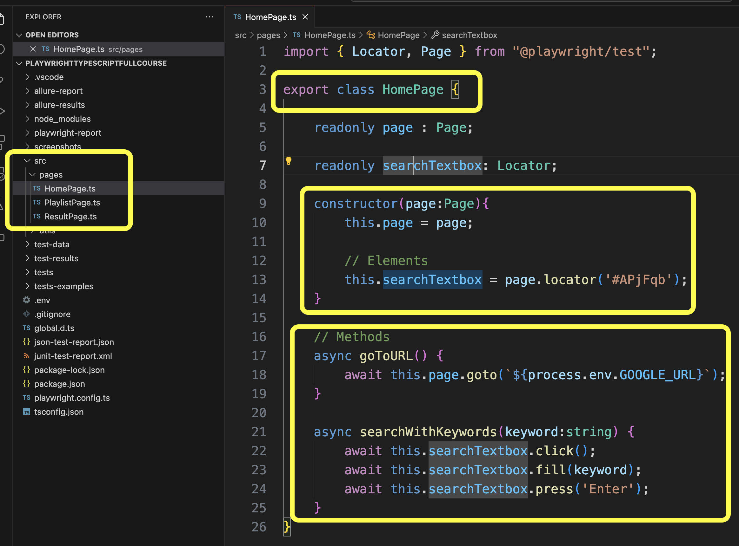

**- Sample Page Object Model Test:**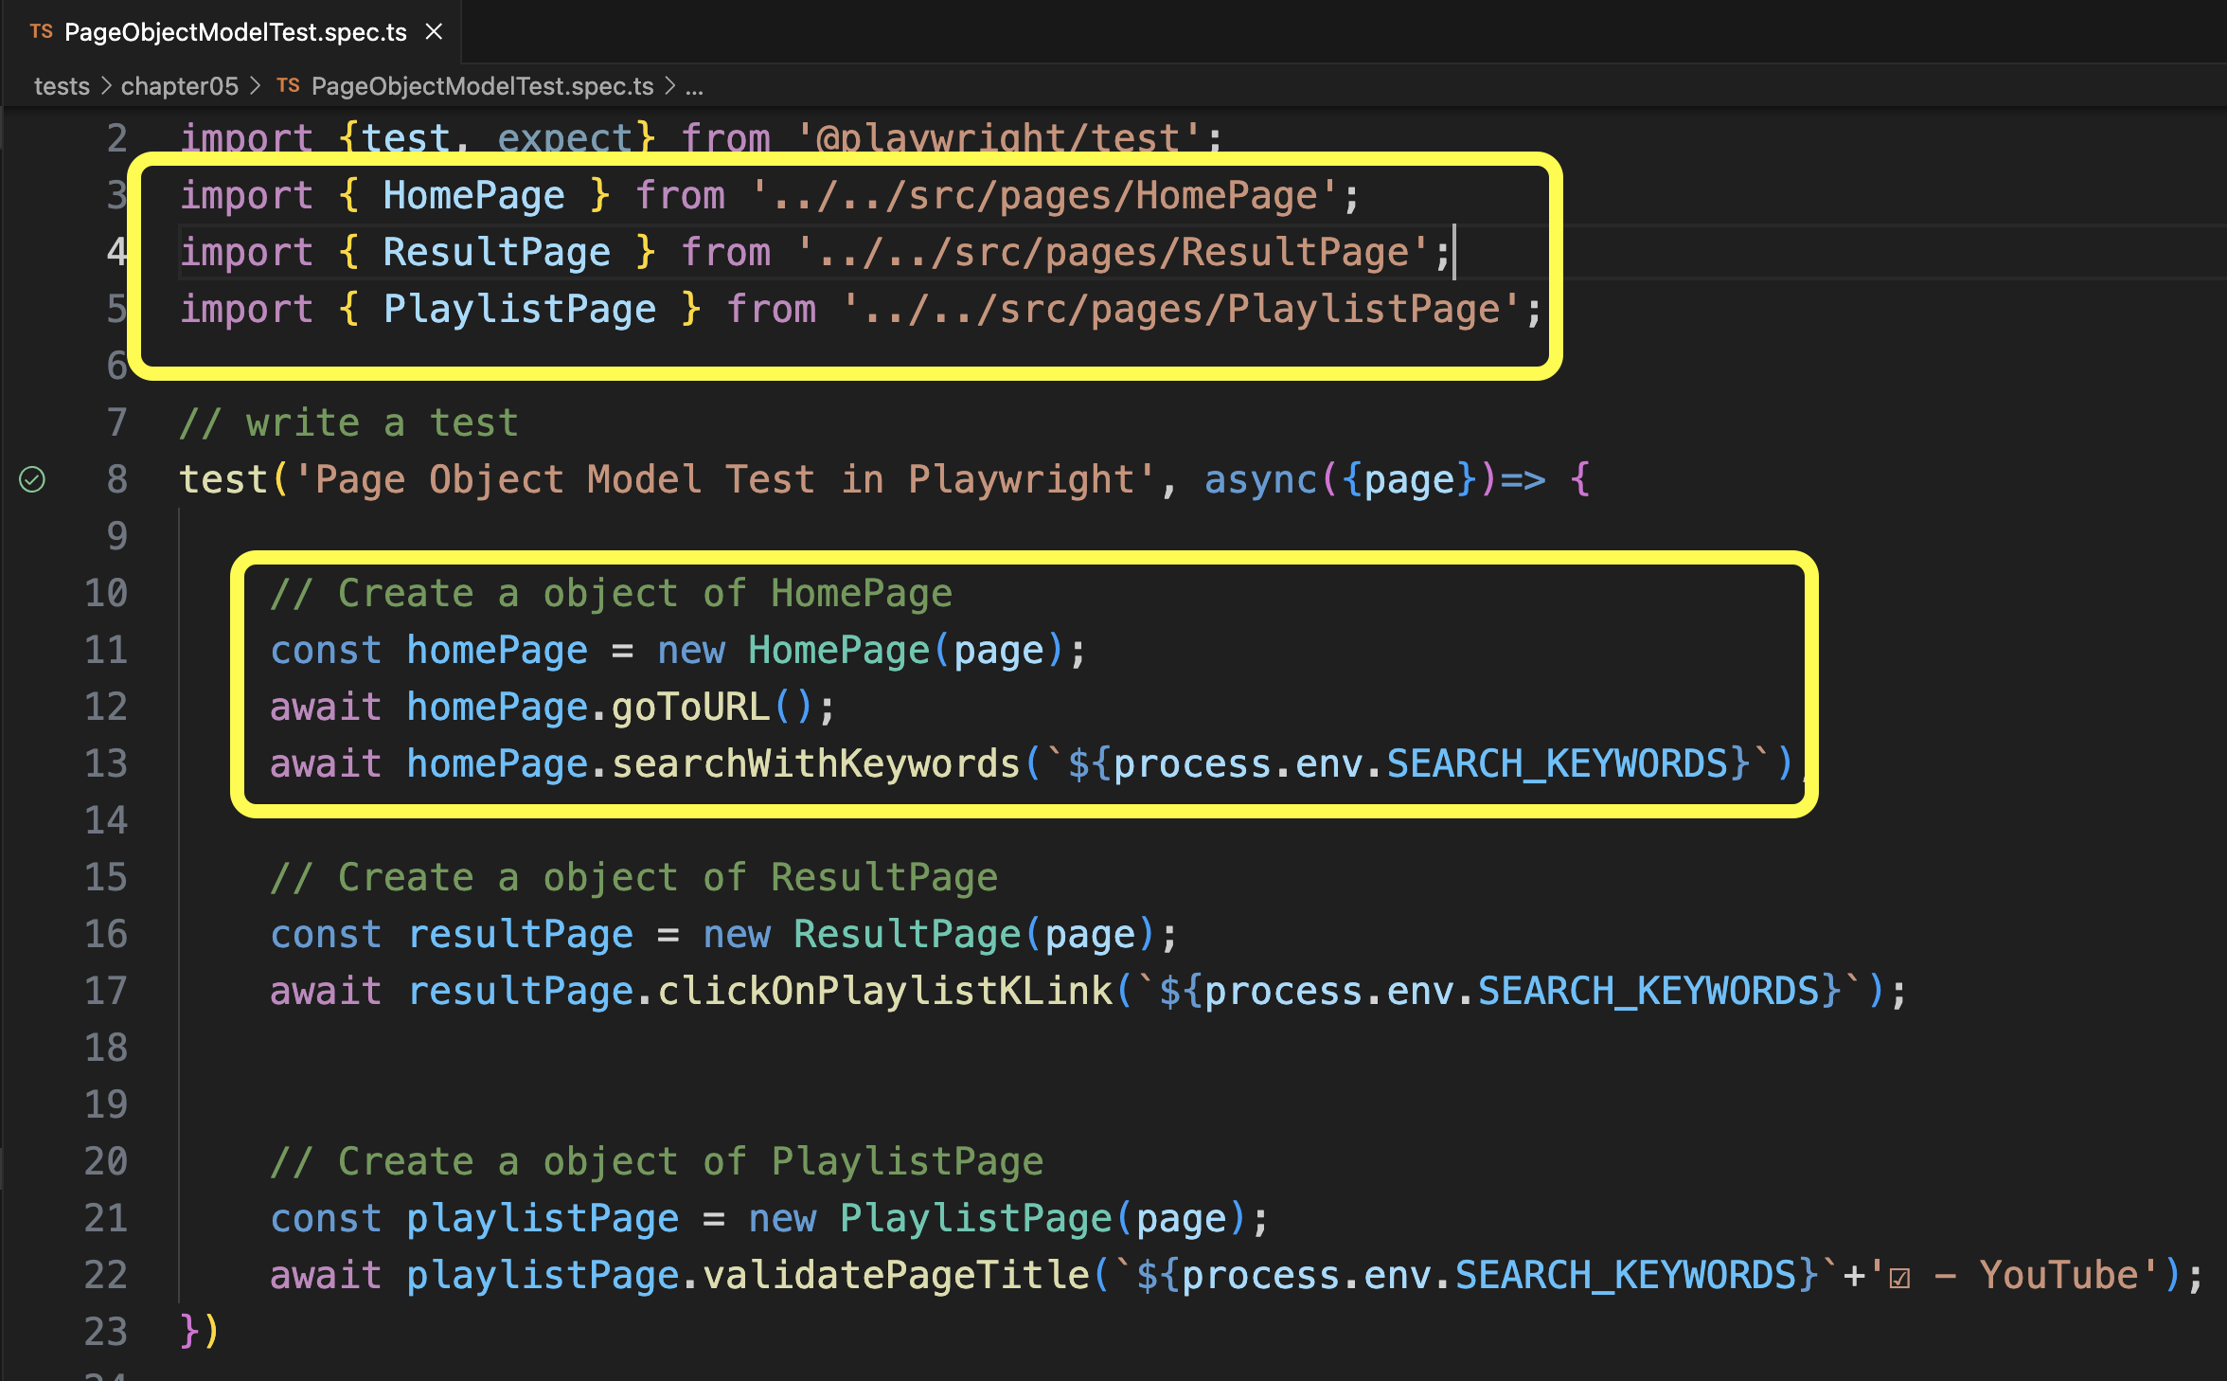

5.6 How to Execute Only Changed Spec/Test Files in Playwright?

- Command:

npx playwright test - -only-changed

# <https://youtu.be/YmjQNbSWhcI?si=MhyAjlFcqM_e-6xK>

[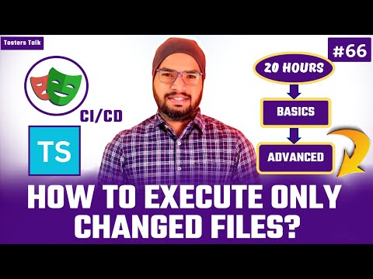](https://www.youtube.com/embed/YmjQNbSWhcI?feature=oembed)

# 5.7 How to maximize browser & set viewport size in Playwright?

* + launchOptions

launchOptions : {

args: ['--start-maximized']

},

How to Set Viewport Size?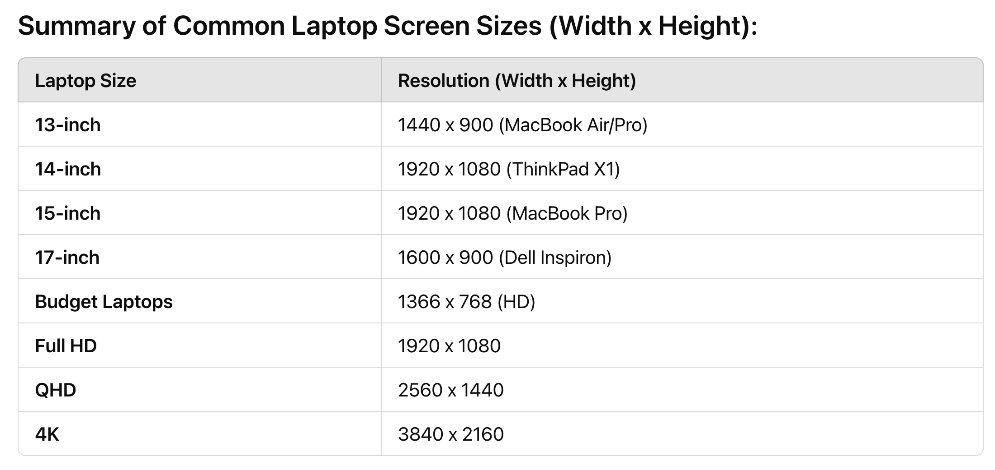

<https://youtu.be/xTeFNFtoofk?si=BFj_dC4-m1turWvF>

[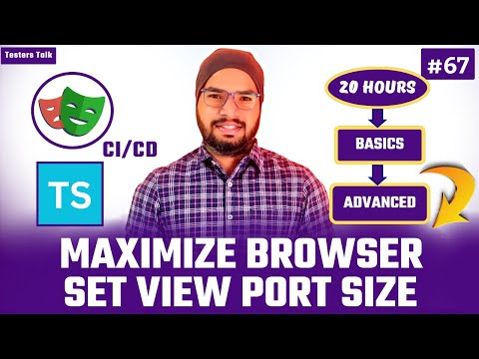](https://www.youtube.com/embed/xTeFNFtoofk?feature=oembed)

5.8 Fixture -

- How to implement Global Hooks - BeforeEach & AfterEach

<https://youtu.be/HqJ0LRy5KME?si=rLmpcWo91jjb1i4u>

[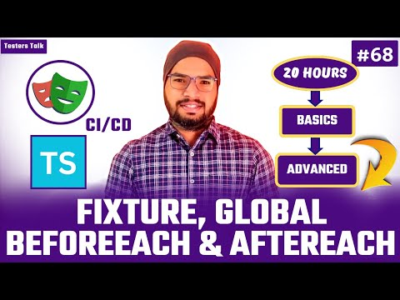](https://www.youtube.com/embed/HqJ0LRy5KME?feature=oembed)

5.9 How to Optimize Page Object Model Tests with Fixture

<https://youtu.be/jftW1abJqJE?si=LEIzxjZPheBmeTTj>

[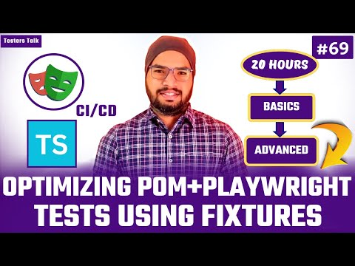](https://www.youtube.com/embed/jftW1abJqJE?feature=oembed)

5.10 Run Tests on Multiple Environments – QA, STAGE, DEV, PROD etc.

- Create environment variable

- Create test data for each environment

- Create an interface for type safety

- Create utility method to read all the files

- Create playwright test

- Run playwright test

<https://youtu.be/w3pR73rsKBU?si=ykKOuz8_QLTyVgLH>

[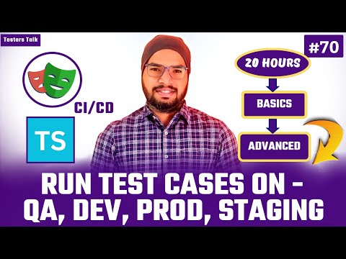](https://www.youtube.com/embed/w3pR73rsKBU?feature=oembed)

5.11 Global Setup & TearDown

- How to Save Authentication?

Chapter- 06

6.1 Create POST API Request using Static Request Body in Playwright & TypeScript

- Use Case

- Create JSON file

- Create Spec file

- Automate POST API request

- Print JSON API response

- Validate status code, status text, response type.

- Validate property/keys

- Validate API response body

<https://youtu.be/k8IHwDrqVxU?si=HhNRd60eIx3Hcf3Z>

[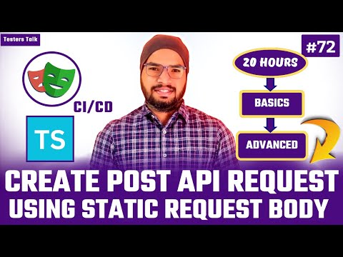](https://www.youtube.com/embed/k8IHwDrqVxU?feature=oembed)

6.2 Create POST API Request using Dynamic Request body in Playwright & TypeScript

- Prepare dynamic API request body JSON file

- Create utility method

- Automate POST API request

- Print JSON API response

- Validate status code, status text, response type.

- Validate property/keys

- Validate API response

<https://youtu.be/MXH2MNPHkFw?si=iwVc-CTUncbiiAtz>

[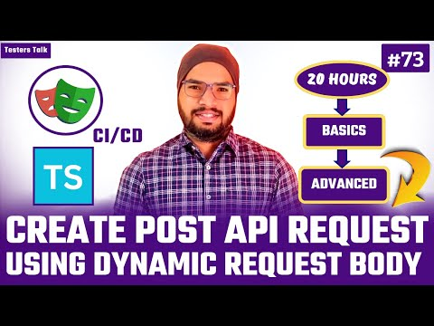](https://www.youtube.com/embed/MXH2MNPHkFw?feature=oembed)

6.3 How to Create Dynamic POST API Request using Playwright & TypeScript

- Plugin:

npm install @faker-js/faker

<https://youtu.be/zXCARAWdmv4?si=jmd3276RHzbFQmoQ>

[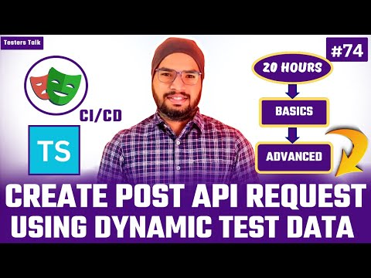](https://www.youtube.com/embed/zXCARAWdmv4?feature=oembed)

6.4 Create Dynamic POST API Request with TypeSafety using Playwright & TypeScript

<https://youtu.be/k4V5MdiaqmE?si=NQT1ceeow8-KB0gb>

[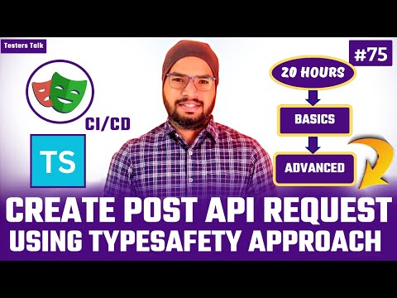](https://www.youtube.com/embed/k4V5MdiaqmE?feature=oembed)

6.5 How to Create GET API Request using Playwright & TypeScript?

- Manual Use Case

- Automate GET API Request

<https://youtu.be/v6kkPVf1bbU?si=hZG_OKGAuZSHOwaz>

[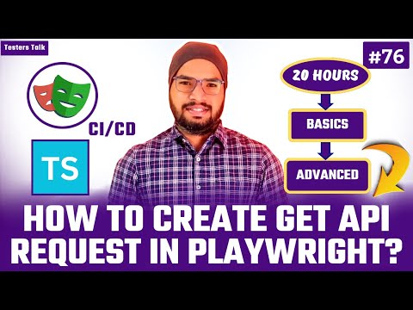](https://www.youtube.com/embed/v6kkPVf1bbU?feature=oembed)

6.6 How to Pass Query Parameters in Playwright API Automation Testing?

- Manual Use Case

- Automate GET API Request using Query Parameters

<https://youtu.be/cw-ZbZjhJFM?si=_ewDXxbFpDiSIiMh>

[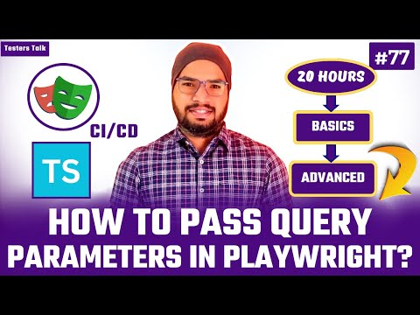](https://www.youtube.com/embed/cw-ZbZjhJFM?feature=oembed)

6.7 How to Create PUT API Request using Playwright & TypeScript

- Manual Use Case

- Generate token

- Automate PUT API Request

<https://youtu.be/nLFZzpLhw2o?si=MNbLjtj6xr6e6sm0>

[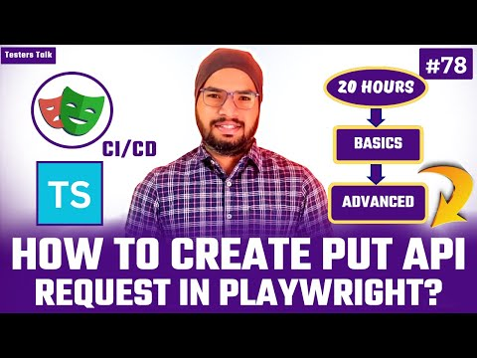](https://www.youtube.com/embed/nLFZzpLhw2o?feature=oembed)

6.8 How to Create PATCH API Request using Playwright & TypeScript

- Manual Use Case

- Automate PATCH API Request

<https://youtu.be/6gE-mf68duA?si=eNDCXzi3NLYTRIuN>

[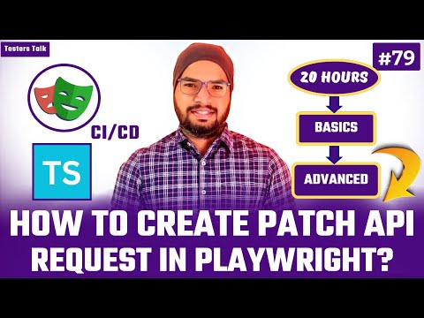](https://www.youtube.com/embed/6gE-mf68duA?feature=oembed)

6.9 How to Create DELETE API Request using Playwright & TypeScript

- Manual Use Case

- Automate End to End API Testing flow

<https://youtu.be/VcidovRv_Ac?si=R5xP8QZlxpi5Axts>

[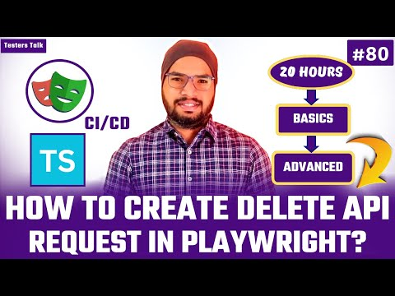](https://www.youtube.com/embed/VcidovRv_Ac?feature=oembed)

6.10 What is API Mocking?

<https://youtu.be/ufKlOqH5AJE?si=NKpQ5qpLEFOXzLPb>

[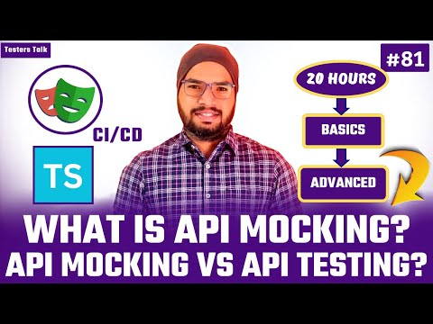](https://www.youtube.com/embed/ufKlOqH5AJE?feature=oembed)

API mocking is a technique to simulate the behavior of an API or service without calling actually API. This is extremely beneficial in various ways such as Isolation, Speed & Control etc.

Example: Banking Transactions, Gift Card & Third-Party API’s etc.

- API Mocking vs API Testing?

- 3 Ways of API Mocking in Playwright

- API Mocking vs API Testing

|  |  |  |
| --- | --- | --- |
| **Aspect** | **API Mocking** | **API Testing** |

|  |  |  |
| --- | --- | --- |
| **Purpose** | Simulate the behavior of an API without actual backend logic. | Verify the actual behavior, performance, and functionality of an API. |

|  |  |  |
| --- | --- | --- |
| **When to Use** | When the real API is unavailable or incomplete. | When the real API is ready and needs validation. |

|  |  |  |
| --- | --- | --- |
| **Environment** | Isolated, often in development or early stages. | QA or Staging environment where the actual API is deployed. |

|  |  |  |
| --- | --- | --- |
| **Focus** | Creating controlled, predictable responses. | Ensuring that the API works correctly in various scenarios. |

|  |  |  |
| --- | --- | --- |
| **Response Behavior** | Predefined, simulated responses based on inputs. | Real responses from the actual API, depending on the backend logic. |

|  |  |  |
| --- | --- | --- |
| **Network Calls** | No real network calls; local mock server or tool. | Real network calls to the actual API endpoint. |

|  |  |  |
| --- | --- | --- |
| **Error Handling** | Simulated errors or predefined failure responses. | Testing real error scenarios (e.g., 500 errors, network issues). |

|  |  |  |
| --- | --- | --- |
| **Testing Types** | Typically used in unit/integration development phases. | Covers functional, performance, security, and load testing. |

|  |  |  |
| --- | --- | --- |
| **Tools** | WireMock, Mockoon, Mountebank, Postman (mock mode). | Postman, SoapUI, RestAssured, JUnit, Jest, etc. |

|  |  |  |
| --- | --- | --- |
| **Use Cases** | Early-stage development, testing interactions before API completion. | Verifying full functionality, security, and performance of a live API. |

|  |  |  |
| --- | --- | --- |
| **Data Source** | Static or predefined data responses. | Real-time data from the API (e.g., database queries, live data). |

|  |  |  |
| --- | --- | --- |
| **Cost** | Low cost as no real API calls are made. | May incur costs if testing against paid or rate-limited APIs. |

|  |  |  |
| --- | --- | --- |
| **Flexibility** | High flexibility in simulating different scenarios and responses. | Less flexibility; testing is dependent on the actual API and its limitations. |

**- 3 Ways of API Mocking in Playwright**

- API Requests

- API Response

- API Mocking from HAR Files

- Recording, Modifying & Replaying

**6.11 How to Mock API Requests in Playwright?**

<https://youtu.be/zX1AiNF3USM?si=bfzNJFGczh2_HPFD>

[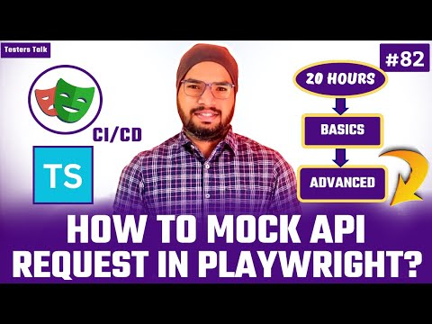](https://www.youtube.com/embed/zX1AiNF3USM?feature=oembed)

**6.12 How to Mock API Response in Playwright?**

<https://youtu.be/16gbSnCW71c?si=8hmlH9iTkqeMe2se>

[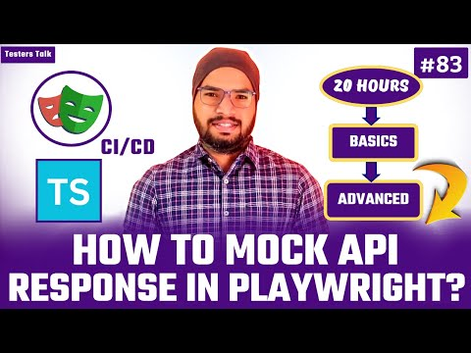](https://www.youtube.com/embed/16gbSnCW71c?feature=oembed)

**6.13 How to Record .HAR file, Modify .HAR file & Replaying from .HAR file in Playwright & TypeScript**

<https://youtu.be/1SyOKq3bH4U?si=UFXQSM1X96wItD2k>[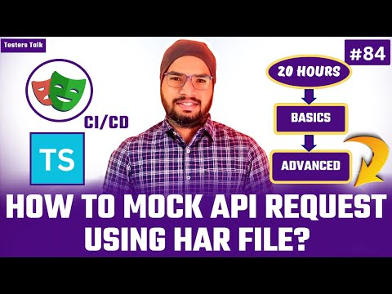](https://www.youtube.com/embed/1SyOKq3bH4U?feature=oembed)

Chapter- 07

**7. Jenkins, Azure DevOps Pipeline & GitHub Actions**

**7.1 How to Integrate Playwright with Jenkins + GitHub**

**- How to Create GitHub Repository & Push Code?**

<https://youtu.be/KTlL0-64K9I?si=yxGhfdLCnVMkK2GF>

[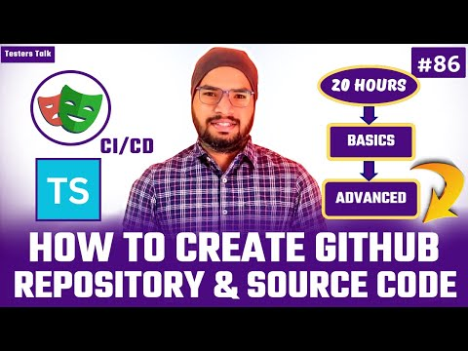](https://www.youtube.com/embed/KTlL0-64K9I?feature=oembed)

**- Generate PAT (Personal Access Token) for GitHub?**

<https://youtu.be/-kut2qhCHlA?si=khQ9xa9zguyNJADo>

[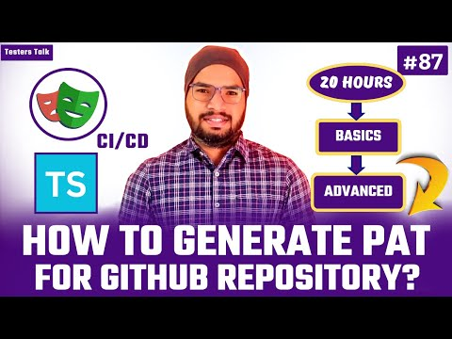](https://www.youtube.com/embed/-kut2qhCHlA?feature=oembed)

**- How to Download & Setup Jenkins?**

<https://youtu.be/qzNerpJQevM?si=48IrvKsM43JLA4wj>

[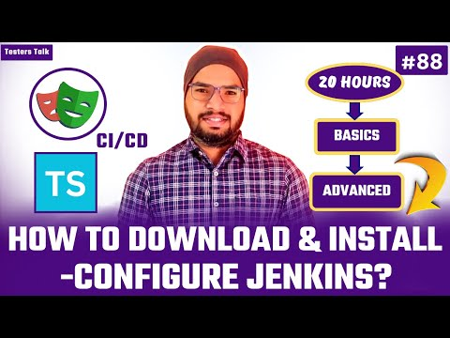](https://www.youtube.com/embed/qzNerpJQevM?feature=oembed)

**- Install Plugins:**

- NodeJS Plugin, Git Plugin, JUnit Plugin & Allure Plugin.

<https://youtu.be/v4SW5pSIHL0?si=e_k2yvqhMdyBt3Dp>

[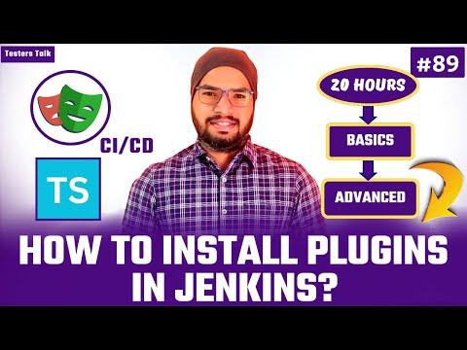](https://www.youtube.com/embed/v4SW5pSIHL0?feature=oembed)

**- How to Add GitHub PAT token in Jenkins?**

<https://youtu.be/_5k9irhkkOg?si=phm85rgHqEvVdRdB>

[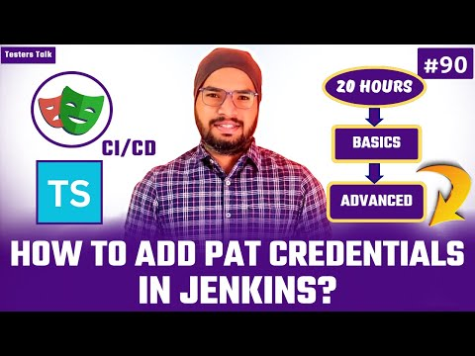](https://www.youtube.com/embed/_5k9irhkkOg?feature=oembed)

**- How to Create Jenkins Job & Run Playwright Tests?**

<https://youtu.be/zALfXCHv1Ko?si=XpyUJ0CQXInUaLZ4>

[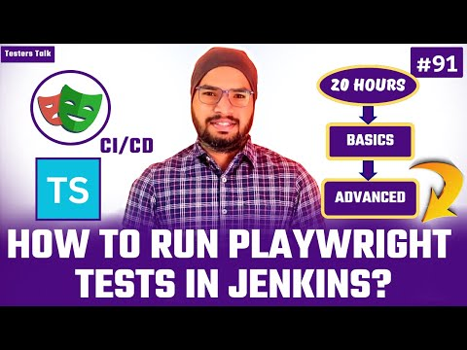](https://www.youtube.com/embed/zALfXCHv1Ko?feature=oembed)

**- How to Attach Artifacts (playwright-report)**

<https://youtu.be/GvdEDXcY7O8?si=g1cjI1cvCbE1MulE>

[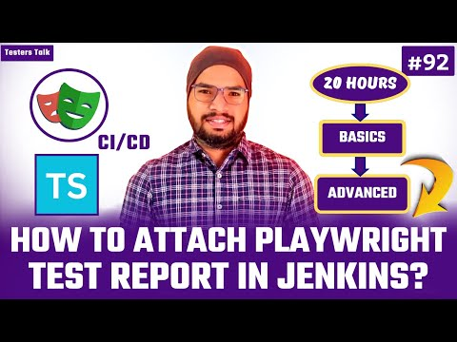](https://www.youtube.com/embed/GvdEDXcY7O8?feature=oembed)

**- How to Publish Junit Test Results in Jenkins?**

<https://youtu.be/dujbT9s16gM?si=XLHfk6ouKba4qY3j>

[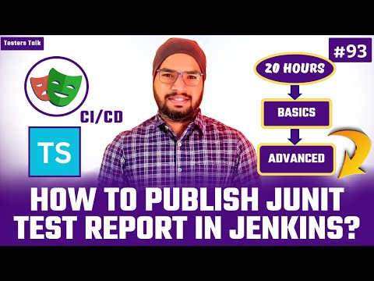](https://www.youtube.com/embed/dujbT9s16gM?feature=oembed)

**- How to Publish Allure Report in Jenkins?**

<https://youtu.be/SDzIsiPV6Cw?si=nkaUIWbLgDJPC-_y>

[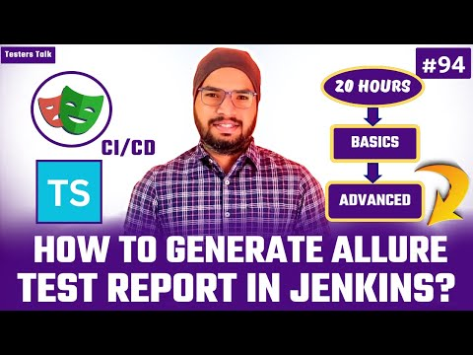](https://www.youtube.com/embed/SDzIsiPV6Cw?feature=oembed)

-> How to Create GitHub Repository?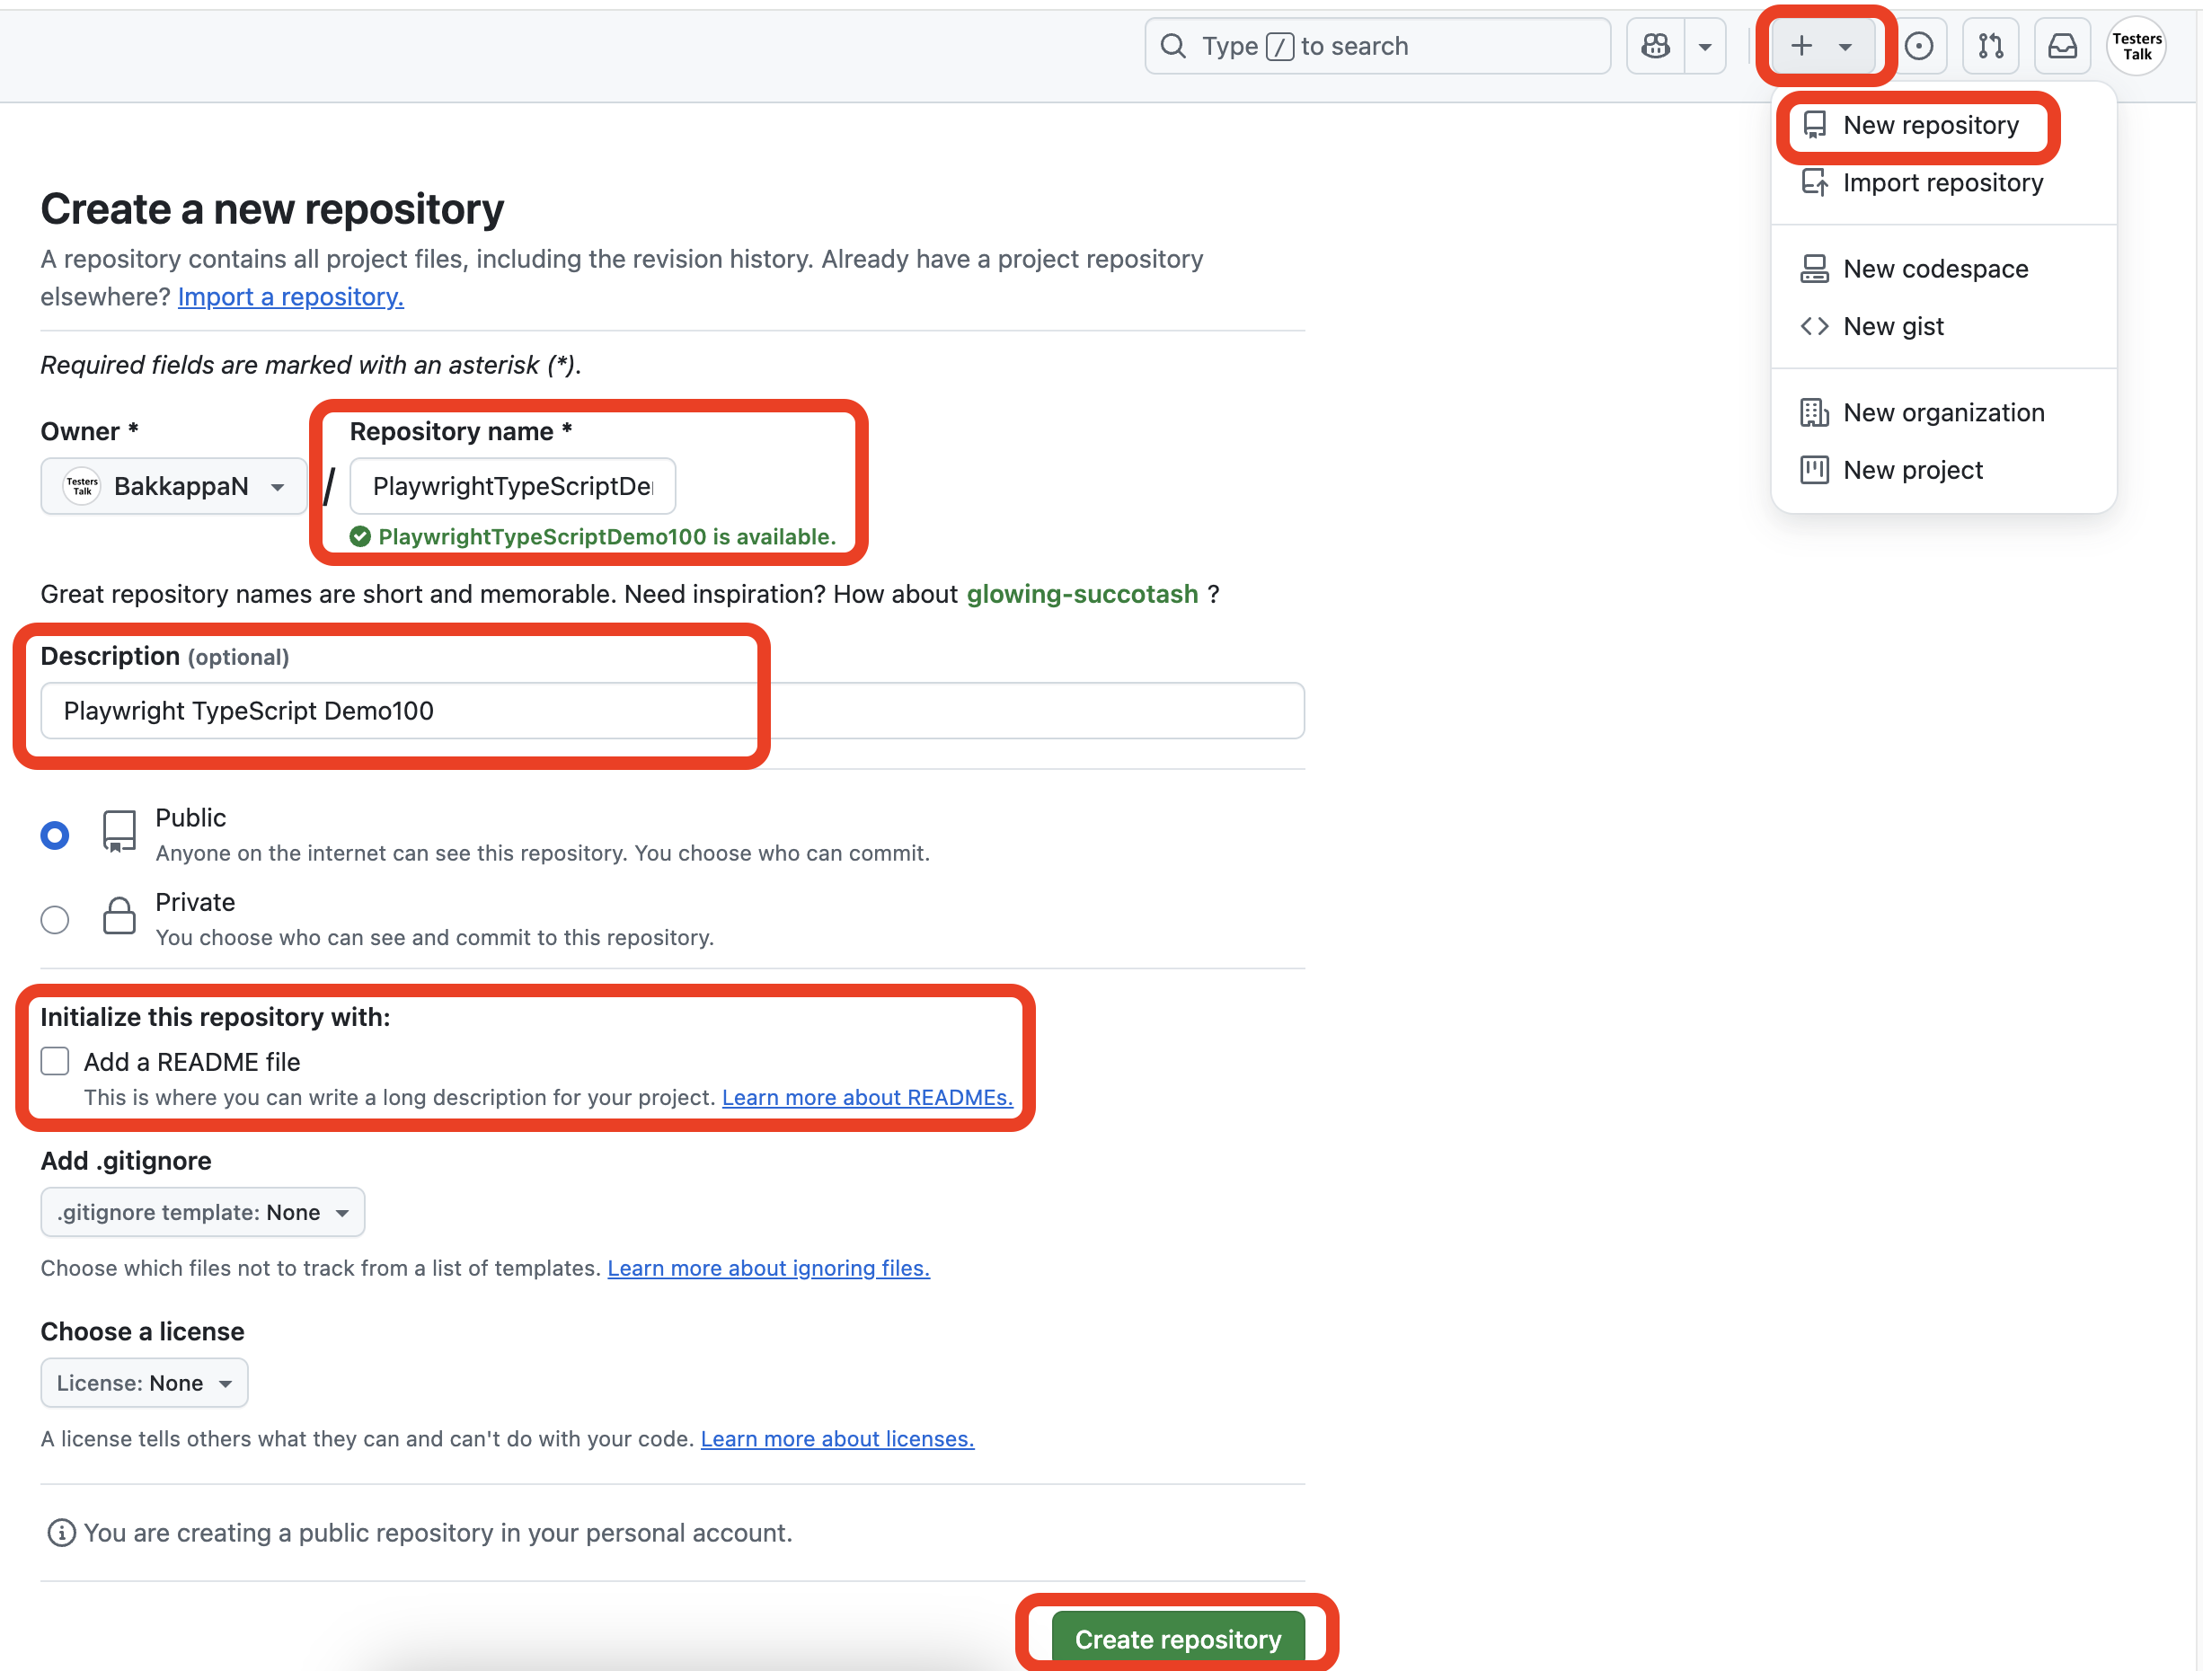

-> How to push source code to GitHub Repository?

git init

git add *

git commit -m "first commit"

git branch -M main

git remote add origin <https://github.com/BakkappaN/>

git push -u origin main

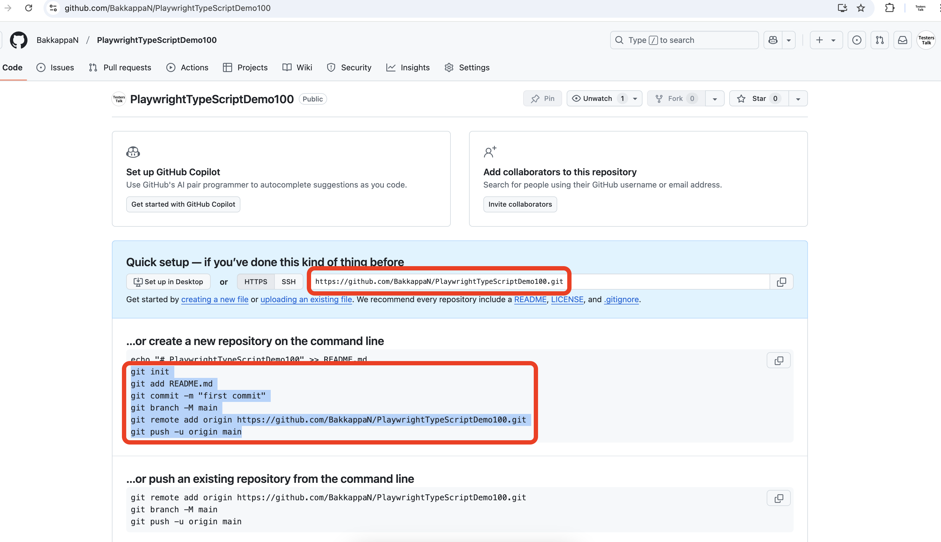

-> Steps to Generate GitHub Personal Access Token (PAT)

1. Go to GitHub and log in to your account.
2. Click on your profile picture in the top-right corner and select Settings.
3. In the left sidebar, click Developer settings.
4. Click Personal access tokens.
5. Click Generate new token.
6. Provide a descriptive name for the token (e.g., "Jenkins CI Token").
7. Select the required scopes (e.g., repo, workflow, or other necessary permissions).
8. Click Generate token.
9. Copy the token immediately as you won't be able to view it again.

**7.2 How to Integrate Playwright with Azure DevOps Pipeline**

- Download & Install GIT - <https://git-scm.com/downloads>

- How to Install Azure Repos extension in VS Code

- How to Create New Repository in Azure DevOps?

<https://youtu.be/SxLA43-JAqU?si=f_SWhZh8539hRsYj>

[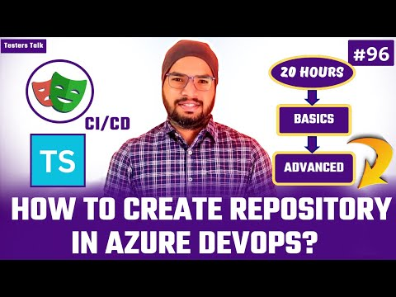](https://www.youtube.com/embed/SxLA43-JAqU?feature=oembed)

**- How to Push Source Code from VS Code to Azure DevOps?**

<https://youtu.be/5qWC0rNip9g?si=XYfyd8lvjyAZhnRL>

[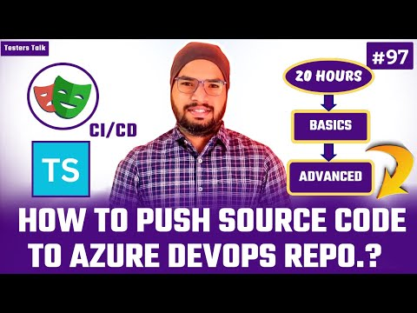](https://www.youtube.com/embed/5qWC0rNip9g?feature=oembed)

**- How to Create .yml(YAML) file?**

<https://youtu.be/ODGKrCKx0xY?si=2pssTMSqiLEatyT->

[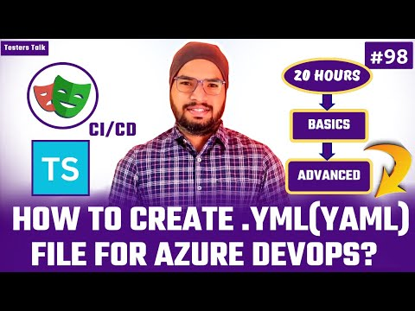](https://www.youtube.com/embed/ODGKrCKx0xY?feature=oembed)

**- How to Create Azure DevOps Pipeline?**

<https://youtu.be/hfcR3Kxr-lU?si=HLSplj1Tf2dsUb_u>

[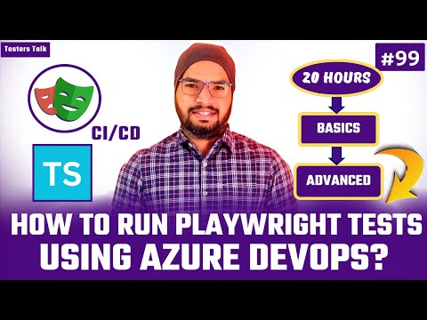](https://www.youtube.com/embed/hfcR3Kxr-lU?feature=oembed)

**- How to Run Playwright Tests using ADO pipeline?**

<https://youtu.be/y_KsVBSdZs8?si=11enVfed4v_82iXg>

[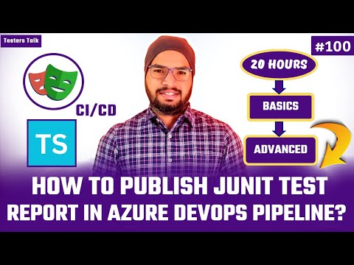](https://www.youtube.com/embed/y_KsVBSdZs8?feature=oembed)

**- How to Publish JUnit Test Results in ADO?**

<https://youtu.be/y_KsVBSdZs8?si=rmKaI-BBkNDhEcf7>

[](https://www.youtube.com/embed/y_KsVBSdZs8?feature=oembed)

**- How to Attach “playwright-report” in ADO as Artifacts?**

<https://youtu.be/KiOJCTYaePc?si=5806zlmv4WPKXuL8>

[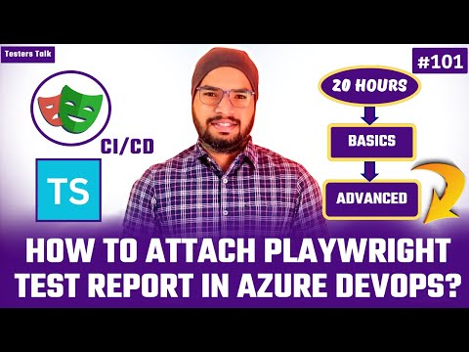](https://www.youtube.com/embed/KiOJCTYaePc?feature=oembed)

**- How to Update Test Case Status Automatically in Test Plan (Pipeline + Local)?** <https://youtu.be/aT_1uulU2dE?si=l6lRTRTTFCzO8Z2y>

[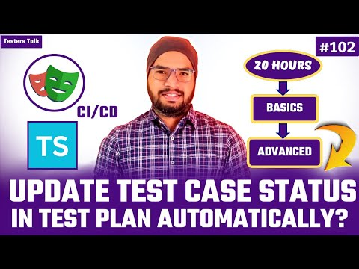](https://www.youtube.com/embed/aT_1uulU2dE?feature=oembed)

**7.3 Integrate Playwright with GitHub Actions:**

**- How to Create a .yml(YAML) File?**

<https://youtu.be/mAP7yRviP0k?si=SADoKF6VrVCIAwC0>

[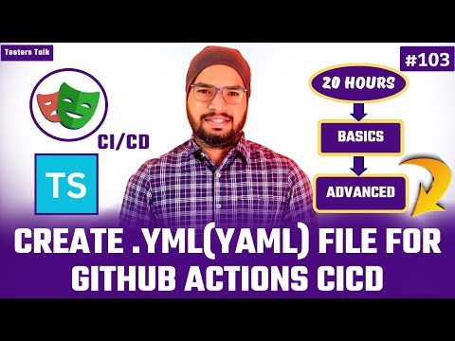](https://www.youtube.com/embed/mAP7yRviP0k?feature=oembed)

**- How to Run Playwright Tests using GitHub Actions?**

- Workflow - Auto Trigger

- Workflow - Manual Trigger

**- How to Attach “playwright-report“ as Artifacts**

<https://youtu.be/eU97jYluRPA?si=CgOn1jLkKA19ksnr>

[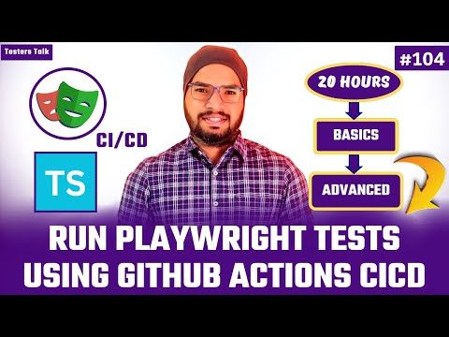](https://www.youtube.com/embed/eU97jYluRPA?feature=oembed)

<https://youtu.be/gI3L2AXndFE?si=o3dTlq_IiSmJfJbU>

[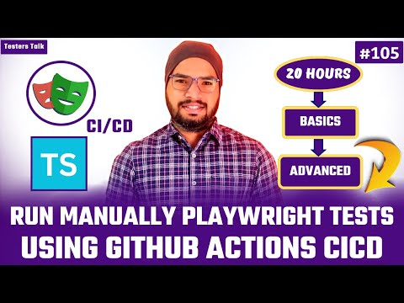](https://www.youtube.com/embed/gI3L2AXndFE?feature=oembed)

**8.1 Upload File & Validate**

**8.2 Download File & Validate File Name**

**8.3 Validate Downloaded Excel File Content**

**8.4 Validate Downloaded XML File Content**

**8.5 Validate Downloaded PDF File Content**

**8.6 Validate Downloaded Word Doc. File Content**

THE END…